Operating System Questions:

Unit – 1

Q1. What is an Operating System?

Ans. An Operating System is a system Software that acts as an
intermediary/interface between a user of a computer and the computer
hardware.

Computer System = Hardware + Software
Software = Application Software + System Software(OS)

Q2. What is structure of computer?

Ans.
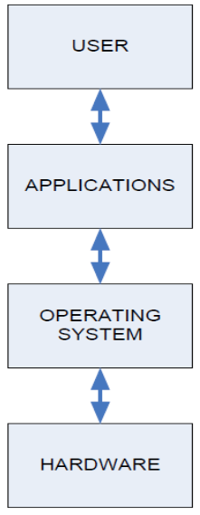

Q3. What is CPU?

Ans. This is the brain of your computer.
➢ It performs all of the calculations.
➢ In order to do its job, the CPU needs commands to perform, and data to
work with.
➢ The instructions and data travel to and from the CPU on the system bus.
➢ The operating system provides rules for how that information gets back and
forth, and how it will be used by the CPU.

Q4. What is RAM?

Ans. This is like a desk, or a workspace, where your computer temporarily stores all of
the information (data) and instructions (software or program code) that it is
currently using.
➢ Each RAM chip contains millions of address spaces.
➢ Each address space is the same size, and has its own unique identifying number
(address).

Q5. What is Batch Operating System?
Ans. A Batch Operating System is a type of operating system where users do not directly interact with the computer.
- Users prepare their jobs (programs and data) offline, often using punch cards, and submit them to the operator.
- The operator groups similar jobs with the same requirements into batches, which are then executed together.
- This system reduces idle time and improves resource utilization by processing jobs in bulk.
Example: IBM's MVS (Multiple Virtual Storage).

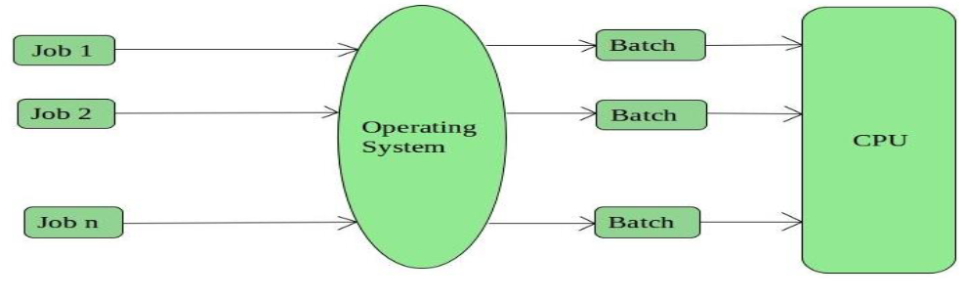
Q6. What is Multiprogramming Operating System?

Ans. • This type of OS is used to execute more than one jobs simultaneously by a single processor.
• It increases CPU utilization by organizing jobs so that the CPU always has one job to execute.
• Multiprogramming operating systems use the mechanism of job scheduling and CPU
scheduling.
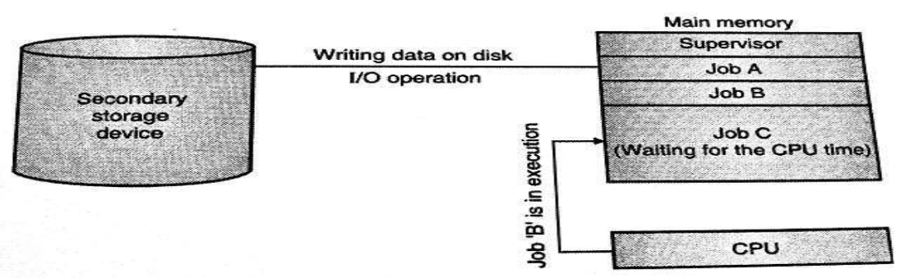

Q7. What is Time-Sharing Operating Systems?

Ans. • Each task is given some time to execute so that all the tasks work smoothly.
• These systems are also known as Multi-tasking Systems.
• The task can be from a single user or different users also.
• The time that each task gets to execute is called quantum.
• After this time interval is over OS switches over to the next task.
➢ One must have to take care of the security and integrity of user programs and data
➢ Data communication problem
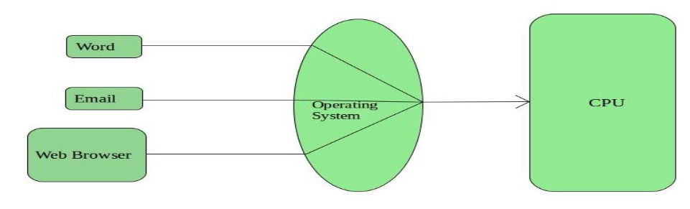

Eg. Multics, Unix, etc.

Q8. What is Multiprocessor operating systems?

Ans. • Multiprocessor operating systems are also known as parallel OS or tightly
coupled OS.
• Such operating systems have more than one processor in close
communication that sharing the computer bus, the clock and sometimes
memory and peripheral devices.
• It executes multiple jobs at the same time and makes the processing
faster.
• It supports large physical address space and larger virtual address space.
• If one processor fails then other processor should retrieve the interrupted
process state so execution of process can continue.
• Inter-processes communication mechanism is provided and implemented in
hardware.

Q9. What is Distributed Operating System?

Ans. • Various autonomous interconnected computers communicate with each other using a shared
communication network.
• Independent systems possess their own memory unit and CPU.
• These are referred to as loosely coupled systems.

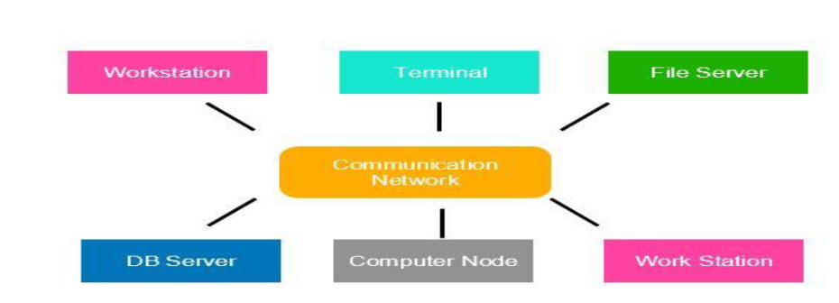

Q10. What is Network Operating System?

Ans. A Network Operating System (NOS) runs on a server and manages data, users, groups, security, applications, and various networking functions. It enables shared access to files, printers, and other resources over a small private network, where the connecting computers, known as client computers, run client software to request specific services from the server. These systems are often referred to as tightly coupled systems.

Examples of Network Operating Systems include Microsoft Windows Server (2003/2008/2012), UNIX, Linux, Mac OS X, Novell NetWare, and BSD.

Q11. What is Real-time Operating System?

Ans. • These types of OSs serve real-time systems.
• The time interval required to process and respond to inputs is very small.
• This time interval is called response time.
• Real-time systems are used when there are time requirements that are very
strict like
➢ missile systems,
➢ air traffic control systems,
➢ robots, etc.

A real-time system is an operating system designed to process data and provide output within strict time constraints, ensuring timely response to external events.
Types of real-time systems:
- Hard Real-Time Systems: Must meet strict deadlines; failure to do so can lead to catastrophic results. Examples include medical devices and flight control systems.
- Soft Real-Time Systems: Prioritizes meeting deadlines but allows some flexibility; occasional deadline misses are acceptable. Examples include video streaming and online gaming systems.

Q12. How Operating System acts as a Resource Manager?

Ans. The operating system (OS) manages various resources in modern computers, including processors, memory, timers, network interfaces, and I/O devices. It ensures orderly and controlled allocation of these resources among multiple programs.
Key functions include:
- Allowing multiple programs to reside in memory and run concurrently.
- Managing resource sharing through time multiplexing (where different programs take turns using the CPU, such as sharing a printer sequentially) and space multiplexing (where resources are shared among programs concurrently).

Q13. What is a thread?

Ans. A thread is a single sequence stream within a process, often referred to as a lightweight process because it shares certain properties with processes. Each thread belongs to one process and operates in a shared memory space, unlike processes that have separate memory spaces. Threads within the same process share their code, data, and OS resources, but each has its own program counter, register set, and stack space.
Advantages:
- Responsiveness: Dividing a process into multiple threads allows immediate return of output when one thread completes its execution.
- Faster Context Switch: Context switching between threads is quicker than between processes, as it involves less overhead.
- Effective Utilization of Multiprocessor Systems: Multiple threads can be scheduled on different processors, speeding up overall process execution.

Q14. What are different thread states?

Ans. When a thread moves through the system, it is always in one
of the five states:
(1) Ready
(2) Running
(3) Waiting
(4) Delayed
(5) Blocked

Q15. Draw a process state diagram.

Ans.

Q16. Difference between wait and block?

Ans. The difference between
the WAITING and BLOCKED transition is that in
WAITING the thread waits for the signal from another
thread or waits for another process to be completed,
meaning the burst time is specific. While, in BLOCKED
state, there is no specified time (it depends on the user
when to give an input).

Q17. What are four basic thread management operations?

Ans.
- Thread Creation: A parent thread creates a child thread.
- Thread Termination: Threads finish their tasks and then terminate, as they do not run indefinitely.
- Thread Join: This operation allows a parent thread to wait for one of its child threads to complete.
- Thread Yield: When a thread yields, it is suspended, allowing the CPU to be allocated to another runnable thread. The yielding thread waits until the CPU becomes available again.

Q18. Explain Types of threads?

Ans.
- User Level Threads: These threads are created without system calls, meaning the kernel does not manage them. They can be easily implemented by users. When user-level threads operate within a single process, kernel-level threads manage them.
- Kernel Level Threads: These threads are recognized by the operating system and have their own thread table for tracking. The kernel manages these threads, which results in longer context switching times compared to user-level threads.

Q19. What are the four basic thread models?

Ans.
- User Level Single Thread Model: Each process has a single thread, and the process table maintains an entry for each process along with its PCB.
- User Level Multi Thread Model: Each process contains multiple threads, managed by a user-level thread library, allowing faster thread switching compared to process switching.
- Kernel Level Single Thread Model: Each process has a single kernel-level thread, with the process table functioning as a thread table.
- Kernel Level Multi Thread Model: Thread scheduling occurs at the kernel level, enabling fine-grained scheduling on a thread basis. If one thread blocks, others can continue running without blocking the entire process.

Q20. Give the view of the OS as User Interface?

Ans. The OS as a user interface provides an abstraction layer between the user and hardware. It offers a convenient way to interact with system resources through a graphical user interface (GUI) or command-line interface (CLI), managing tasks like file handling, program execution, and system configuration.

Q21. What is a system call? Explain the types of system call?

Ans. A system call is a way for programs to request services from the operating system, such as accessing hardware or executing system functions.
Types of system calls:
- Process Control: Create, end, load, or terminate processes.
- File Management: Open, close, read, or write files.
- Device Management: Request or release device resources.
- Information Maintenance: Get system information, set time, or manage system data.
- Communication: Send and receive messages or establish communication links.

Q22. Write different operating system services?

Ans. Different operating system services include:
- Program Execution: Loading and running programs.
- I/O Operations: Managing input and output devices.
- File System Manipulation: File creation, deletion, reading, and writing.
- Communication: Between processes via shared memory or message passing.
- Error Detection: Identifying and responding to errors.
- Resource Allocation: Assigning CPU, memory, and devices.
- Protection and Security: Ensuring authorized access to resources.

Q24. What is spooling?

Ans. Spooling (Simultaneous Peripheral Operation On-Line) is a process where data is temporarily stored in a buffer, allowing devices with different speeds, like printers, to work efficiently. It queues tasks, enabling the CPU to continue processing while slower devices complete their operations in the background.

Q25. What is kernel? Explain types of kernel?

Ans. The kernel is the core part of an operating system that manages system resources, including CPU, memory, and devices, and provides essential services to applications.
Types of kernels:
- Monolithic Kernel: All OS services run in a single kernel space, providing fast access but complex design (e.g., Linux).
- Microkernel: Only basic services run in the kernel, with other services in user space, improving modularity and stability (e.g., Minix).
- Hybrid Kernel: Combines features of monolithic and microkernels, balancing performance and modularity (e.g., Windows NT).

Q26. What is Process? Give the difference between a process and a program.

Ans. A process is an active instance of a program in execution, including its code, data, and system resources.
Difference between process and program:
- Process: Dynamic, currently running instance, uses system resources (CPU, memory).
- Program: Static set of instructions stored on disk, does not consume resources until executed.

Q27. Explain Process Control Block (PCB)?

Ans. A Process Control Block (PCB) is a data structure used by the operating system to manage information about a process. The process control keeps track of many important pieces of information needed to manage processes efficiently. The diagram helps explain some of these key data items

Pointer: It is a stack pointer that is required to be saved when the process is switched from one state to another to retain the current position of the process.
- Process state: It stores the respective state of the process.
- Process number: Every process is assigned a unique id known as process ID or PID which stores the process identifier.
- Program counter: Program Counter stores the counter, which contains the address of the next instruction that is to be executed for the process.
- Register: Registers in the PCB, it is a data structure. When a processes is running and it’s time slice expires, the current value of process specific registers would be stored in the PCB and the process would be swapped out. When the process is scheduled to be run, the register values is read from the PCB and written to the CPU registers. This is the main purpose of the registers in the PCB.
- Memory limits: This field contains the information about memory management system used by the operating system. This may include page tables, segment tables, etc.
- List of Open files: This information includes the list of files opened for a process.

Q28. Difference between process and thread.

Ans. A process is an independent execution unit with its own memory space, while a thread is a smaller, lightweight unit of a process that shares the same memory space.
Key differences:
- Memory: Processes have separate memory, threads share memory within a process.
- Communication: Processes communicate via inter-process communication (IPC), threads communicate directly within the same process.
- Overhead: Processes have higher overhead due to separate resources, threads have lower overhead as they share resources.
Q29. What is Processor Scheduling?
Ans. Processor scheduling is the method by which the operating system allocates CPU time to various processes. It ensures that processes are executed efficiently and fairly by managing which process runs at a given time. Process scheduling is an essential part of a Multiprogramming operating systems.
Types of scheduling:
- Long-term scheduling: Decides which processes are admitted to the ready queue.
- Short-term scheduling: Selects which process in the ready queue gets CPU time.
- Medium-term scheduling: Temporarily swaps processes in and out of memory to optimize performance.

Q30. What are Categories of Scheduling?
Ans.
- Non-Preemptive Scheduling: Resources cannot be taken from a process until it completes execution. Resource switching occurs only when a process terminates or moves to a waiting state.
- Preemptive Scheduling: The OS allocates resources to a process for a fixed time. During this period, a process can switch from the running state to the ready state or from the waiting state to the ready state.

Q31. What are Scheduling Objectives?

Ans. • Be Fair.
• Maximize throughput.
• Maximize number of users receiving acceptible response times.
• Be predictable.
• Balance resource use.
• Avoid indefinite postponement.
• Enforce Priorities.
• Give preference to processes holding key resources.

Q32. Explain Scheduling criteria?

Ans. Scheduling is a process of allowing one process to use the
CPU resources, keeping on hold the execution of another
process due to the unavailability of resources CPU.

• First-Come First-Serve Scheduling, FCFS.
• Shortest-Job-First Scheduling, SJF.
• Priority Scheduling.
• Round Robin Scheduling.

Q33. What is Real time scheduling?

Ans. Real-time scheduling involves managing tasks in real-time systems, which require timely processing without delays. These systems operate under fixed time constraints, and tasks must be completed within these limits.
The scheduler, typically a short-term task scheduler, is crucial for minimizing response times for processes rather than merely meeting deadlines. A combination of preemptive and non-preemptive scheduling is often used, allowing time-based interrupts to switch to higher-priority processes.
Key approaches include:
- Static Table-Driven Approaches: These algorithms use static analysis to create advantageous schedules.
- Static Priority-Driven Preemptive Approaches: Similar to the static table-driven approach, these algorithms analyze scheduling statically.
- Dynamic Planning-Based Approaches: Feasible schedules are determined at runtime, executing tasks that meet time constraints.
- Dynamic Best Effort Approaches: Focus on deadlines rather than schedules; tasks may be aborted if deadlines are not met, commonly used in many real-time systems.

Q34. Explain Race condition with suitable example.
Ans. A race condition occurs in a concurrent system when two or more processes access shared resources simultaneously, and the outcome depends on the sequence or timing of their execution. This can lead to unpredictable behavior and errors.

Example: Consider two processes, Process A and Process B, both trying to increment a shared counter variable, counter, initialized to 0.
- Process A reads the value of counter (0), increments it by 1, and prepares to write back the new value (1).
- Process B reads the value of counter (still 0, since Process A hasn't written yet), increments it by 1, and prepares to write back the new value (1).
- Both processes write their results back, so the final value of counter ends up being 1 instead of the expected 2.
This issue occurs because the processes did not synchronize their access to the shared variable, leading to a race condition. Proper synchronization mechanisms, such as locks or semaphores, can help prevent this situation.

Q35. Difference types of Scheduler.
Ans.
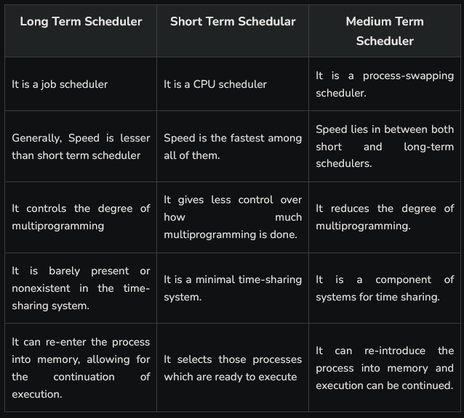

Q36. What is Convoy effect? Explain with suitable example.

Ans. The convoy effect refers to a situation in a multitasking environment where a group of processes or threads are delayed because one or more of them are holding onto a resource (like a CPU or lock) while the others wait for it to become available. This can lead to inefficient resource utilization and increased wait times for all processes involved.

Explanation and Example
Consider a scenario with three processes (P1, P2, P3) that need to access a shared resource, such as a printer. Assume each process requires the printer for a certain amount of time, and they arrive at the resource in the following order:
- P1 arrives and begins using the printer for 5 seconds.
- P2 arrives while P1 is still using the printer and has to wait.
- P3 arrives while P1 is still using the printer and has to wait as well.
After 5 seconds, P1 finishes and releases the printer. However, because P2 and P3 have been waiting, they can now begin using the printer one after the other:
- P2 uses the printer for 4 seconds.
- P3 uses the printer for 6 seconds.
In this case, while P1 was using the printer, both P2 and P3 were unable to proceed with their tasks. After P1 released the resource, P2 and P3 utilized it sequentially, creating a "convoy" effect.
Q37.

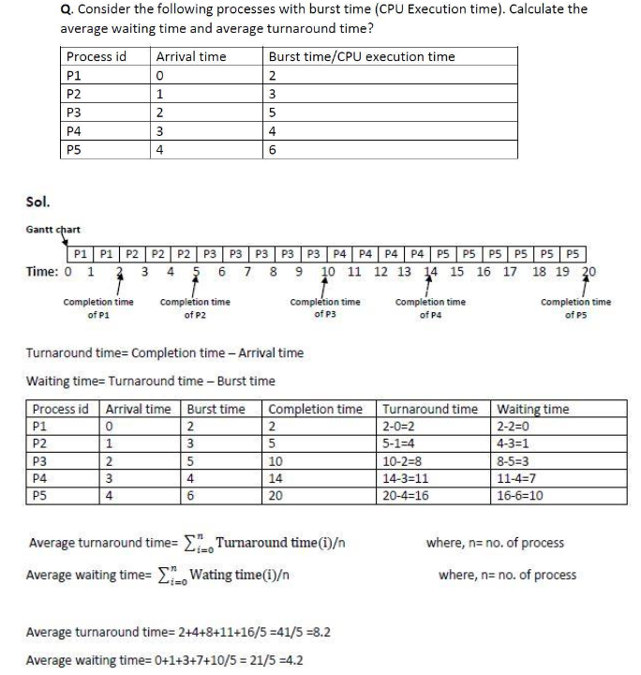

Q38.
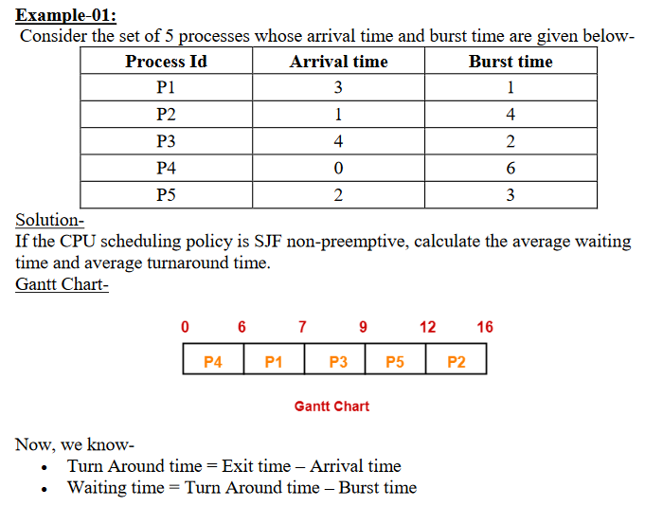
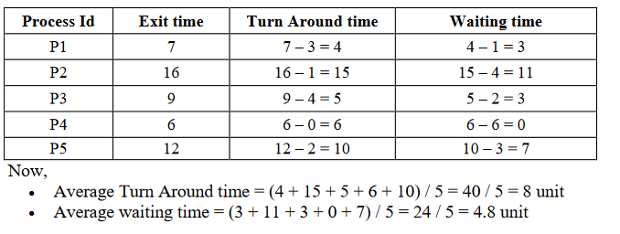

Q 39. What is Multilevel Queue Scheduling?

Ans.

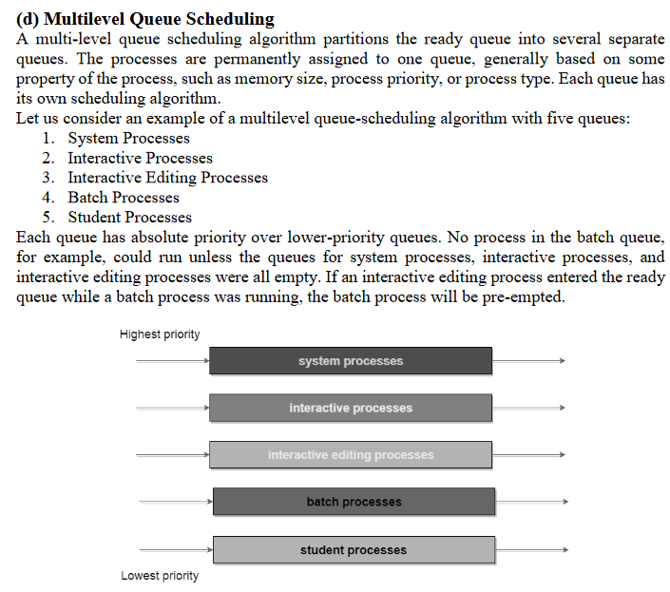

Q40.
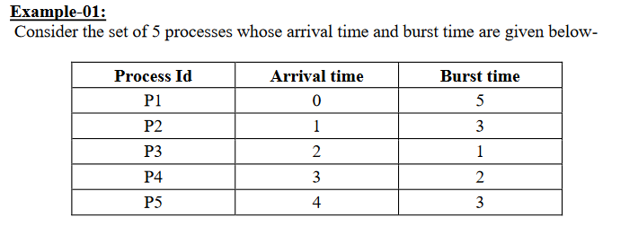

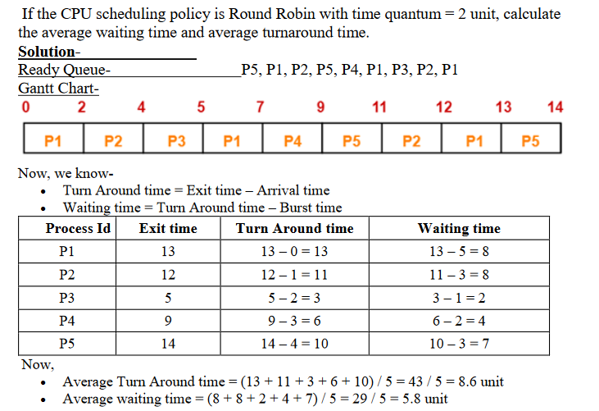

Operating System Questions:

Unit – 2

Q1. What is Process Synchronization?

Ans. Process synchronization ensures that when two or more processes cooperate, their execution order is preserved to avoid conflicts and incorrect outputs.

- A cooperative process can influence or be influenced by the execution of another process, necessitating synchronization.
- The method used to maintain the correct order of execution for these cooperative processes is referred to as process synchronization.
Q2. What is Critical Section?
Ans. A Critical Section refers to a part of a program or process where shared resources are accessed and modified. In a multi-threaded or multi-process environment, it is crucial to ensure that only one process or thread can enter its critical section at a time to prevent data inconsistencies and conflicts.
Q3. What is Mutual Exclusion in Critical Section?
Ans. Mutual Exclusion is a property of process synchronization that ensures that no two processes can be in the critical section simultaneously.
- This property prevents concurrent access to shared resources, avoiding potential conflicts and data inconsistencies.
- By enforcing mutual exclusion, the integrity of shared data is maintained, ensuring that processes execute in a controlled and predictable manner.
Q4. What are the conditions required for Mutual Exclusion? What are approaches to implement it?
Ans. The conditions required for Mutual Exclusion are as follows:
- Mutual Exclusion: Only one process can be in the critical section at a time. If one process is executing in its critical section, all other processes must be excluded from entering their critical sections.
- Hold and Wait: A process holding at least one resource is waiting to acquire additional resources. This condition must be managed to avoid deadlock.
- No Preemption: Resources cannot be forcibly removed from a process holding them; a process must voluntarily release its resources.
- Circular Wait: There exists a circular chain of processes, each waiting for a resource held by the next process in the chain. This condition should be prevented to avoid deadlock scenarios.
The approaches to implementing mutual exclusion include:
- Software Solutions:
  - Peterson’s Algorithm: A classical algorithm for two processes that ensures mutual exclusion through the use of flags and a turn variable.
  - Locks: Software mechanisms like spinlocks or mutexes that allow a process to acquire a lock before entering the critical section and release it afterward.
- Hardware Solutions:
  - Atomic Instructions: Use of atomic operations (like test-and-set or compare-and-swap) provided by the hardware to ensure that certain operations are completed without interruption.
- Semaphores:
  - A synchronization tool that uses counters to control access to shared resources. A binary semaphore (mutex) can be used for mutual exclusion.
Q5. What are Semaphores?
Ans. Semaphores are synchronization variables used to coordinate the activities of multiple processes in a computer system, enforcing mutual exclusion and avoiding race conditions.
They provide two key operations: wait (P), which decrements the semaphore value and may block the process if the value is zero, and signal (V), which increments the value and potentially wakes up a blocked process.
Semaphores are crucial for implementing critical sections—code regions that must be accessed by only one process at a time—allowing processes to coordinate access to shared resources like memory or I/O devices. There are two types of semaphores:
- Binary Semaphore (Mutex): Can take values of 0 or 1, initialized to 1, and used for critical section problems with multiple processes.
- Counting Semaphore: Can take a wider range of values, used to control access to resources with multiple instances.
Q6. Explain Dining Philosopher Problem?
Ans. The Dining Philosopher Problem is a classic synchronization problem in computer science that illustrates the challenges of resource sharing among multiple processes. In this scenario, five philosophers sit around a circular table, alternating between thinking and eating. A bowl of noodles is placed in the center, and each philosopher needs both their left and right chopsticks to eat. They can only eat when both chopsticks are available; if not, they must put down one chopstick and resume thinking.

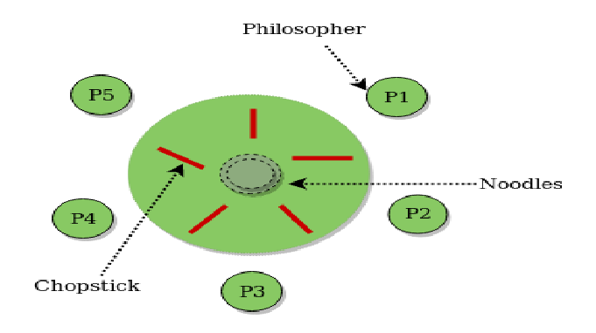

This problem exemplifies concurrency control issues, as philosophers may end up in a deadlock situation if they all try to pick up their chopsticks simultaneously.
A common solution involves using semaphores to represent chopsticks, where the wait operation is used when a philosopher tries to pick up a chopstick, and the signal operation is used when they release it. This ensures that chopsticks are allocated without causing deadlocks or resource starvation among the philosophers.
Q7. Explain barber shop problem.
Ans. The Barber Shop Problem is a classic synchronization scenario that illustrates the coordination between a barber and customers in a barbershop setting. The setup consists of a single barber, one barber chair for cutting hair, and a limited number of waiting chairs for customers. When no customers are present, the barber sits in his chair and sleeps. When a customer arrives, he wakes the barber up.
To effectively manage the interaction between customers and the barber, three semaphores are typically used in the solution:
- Semaphore clients: This counts the number of customers in the waiting area (excluding the customer currently in the barber chair). It ensures that the barber knows when to wake up and serve a customer.
- Semaphore mutex: This semaphore provides mutual exclusion, allowing only one process to access critical sections of code at a time. It ensures that the barber and customers do not interfere with each other's operations, particularly when modifying shared resources.
- Semaphore barber: This binary semaphore indicates whether the barber is idle (0) or working (1). When the barber is busy cutting hair, this semaphore is set to 1, and customers cannot disturb him.
The following outlines the procedure:
- When a customer arrives at the barbershop, they first acquire the mutex semaphore to enter the waiting area safely.
- If there is an available waiting chair, the customer increments the clients semaphore to indicate that there is one more customer waiting.
- If the barber is idle (indicated by the barber semaphore), the customer wakes him up.
- The customer then releases the mutex semaphore and takes a seat in the waiting area.
- When the barber is finished cutting a customer's hair, he checks the clients semaphore to see if there are any waiting customers. If there are, he serves the next customer.
- If the number of customers reaches the limit of available chairs, the new customer leaves without entering the barbershop.
This model ensures that customers do not overwhelm the barber and that the barber only serves customers when they are present. By utilizing semaphores effectively, the barber shop problem can be solved without causing deadlocks or race conditions.

Q8. What is Memory Organization?
Ans. Memory organization refers to the structured arrangement of data in a computer's memory, where it stores instructions and processes data. Memory is essentially an array of bytes or words, each with a unique address. The main purpose of memory is to hold programs and their data during execution, allowing the CPU to fetch instructions based on the program counter's value. This organization is crucial for efficient program execution.
Q9. What is Memory Management?
Ans. Memory management involves allocating and managing memory in a multiprogramming environment, where the operating system occupies a portion of memory while the rest is allocated to multiple processes. It oversees the operations between main memory and disk during process execution, aiming to maximize memory utilization efficiently.
Q10. Why Memory Management is Required?
Ans. • Allocate and de-allocate memory before and after process execution.
• To keep track of used memory space by processes.
• To minimize fragmentation issues.
• To proper utilization of main memory.
• To maintain data integrity while executing of process.
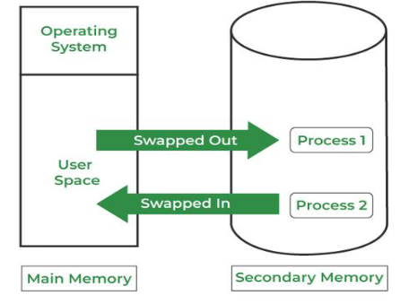

Q11. Explain Memory Hierarchy.
Ans.
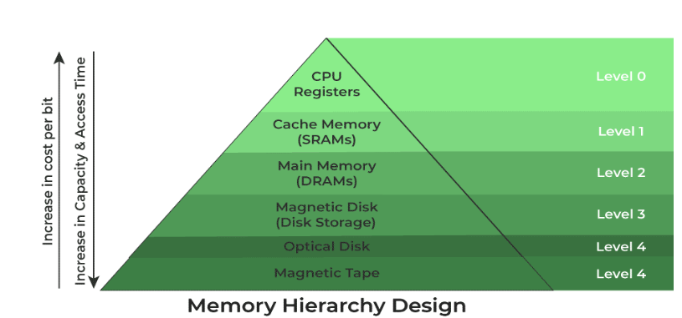

1. Registers
• Registers are small, high-speed memory units located in the CPU. They are
used to store the most frequently used data and instructions.

2. Cache Memory
• Cache memory is a small, fast memory unit located close to the CPU. It
stores frequently used data and instructions that have been recently accessed
from the main memory.

3. Main Memory
Main memory, also known as RAM (Random Access Memory), is the primary
memory of a computer system. It has a larger storage capacity than cache
memory, but it is slower.

4. Secondary Storage
Secondary storage, such as hard disk drives (HDD) and solid-state drives
(SSD), is a non-volatile memory unit that has a larger storage capacity than
main memory. It is used to store data and instructions that are not currently in
use by the CPU.

5. Magnetic Disk
• Magnetic Disks are simply circular plates that are fabricated with either a
metal or a plastic or a magnetized material.

6. Magnetic Tape
• Magnetic Tape is simply a magnetic recording device that is covered with a
plastic film. It is generally used for the backup of data.

Q12. Write down different memory strategies used?

Ans.
- Paging: Paging is a memory management technique used by operating systems to manage large amounts of memory efficiently by dividing it into fixed-size blocks called pages, typically 4KB in size. When a program needs to access a memory address, the operating system checks if the corresponding page is in physical memory (RAM). If the page is not present, the OS retrieves it from the disk and loads it into an available page frame in physical memory, facilitating seamless memory access and efficient resource utilization.

- Segmentation: Memory is divided into segments that represent logical units like procedures or data. A segment table maintains information about each segment, including its base address and length, allowing for flexible memory allocation.
Segmentation is a memory management technique that allows operating systems to allocate memory flexibly by dividing it into segments, each representing a logical unit like a procedure, stack, or data. The OS maintains a segment table containing details about each segment, including its base address and length. When a process requests memory, the OS allocates one or more segments based on its needs. Segmentation offers advantages over other techniques, such as paging, by providing a more intuitive way to manage memory that aligns with the logical structure of programs, improving modularity and ease of use.
- Swapping: Also known as virtual memory, this technique enables the use of more memory than physically available by moving data between RAM and the hard drive. It helps run larger applications and multiple programs simultaneously.
Swapping, also known as virtual memory, is a memory management technique used by modern operating systems to optimize memory resources. It enables a computer to utilize more memory than is physically available by transferring data between RAM and the hard drive. This is crucial for running larger applications and multiple programs concurrently. When a program runs, it requires allocated memory space, and if this space is insufficient, it may crash or malfunction. Virtual memory addresses this issue by swapping data between RAM and the hard drive, effectively allowing the system to manage and use a larger memory space than what is physically installed.
Q13. What is Fragmentation?
Ans. Fragmentation in memory management refers to the inefficiencies created when memory is allocated and deallocated, leading to small blocks of unused memory, known as fragments. This scattered memory can make it challenging to allocate large contiguous blocks, even when the total free memory is adequate.
There are two main types of fragmentation:
- External Fragmentation: This occurs when there are enough total free memory blocks to satisfy a request, but they are not contiguous, preventing their combination into a single larger block.
- Internal Fragmentation: This arises when a program requests more memory than it actually needs, resulting in allocated blocks that are larger than necessary. The unused portion remains wasted and unavailable for other programs.
To manage fragmentation, several techniques can be employed. One approach is compaction, which involves moving allocated memory blocks to create larger contiguous free spaces. While effective, this operation can be resource-intensive, especially in systems with large memory. Another method involves using dynamic memory allocation techniques that allocate memory blocks of appropriate sizes for specific requests, reducing the potential for fragmentation.
Q14. What is Contiguous Memory Allocation?
Ans. Contiguous memory allocation is a memory management technique in which a single contiguous block of memory is allocated to a process or file that requires it. This method ensures that all the allocated memory resides in one place, making it easier for the system to manage and access. In this approach, the available memory space is not fragmented, meaning that unused memory partitions are located together rather than scattered throughout the memory. This can lead to improved performance, as the system can access the memory more efficiently. However, it may also result in issues like external fragmentation over time, as processes are allocated and deallocated memory.

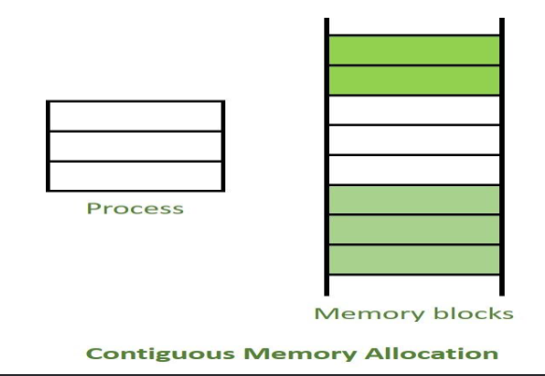
Q15. What is Non-Contiguous Memory Allocation?
Ans. Non-contiguous memory allocation is a method that allocates memory space from different locations to a process based on its requirements, unlike contiguous allocation. This approach leads to a distributed memory pattern, where available memory is scattered. While it helps reduce memory wastage, it can result rise to Internal and external fragmentation.
Q16. Difference between Contiguous and Non-contiguous Memory Allocation.
Ans.
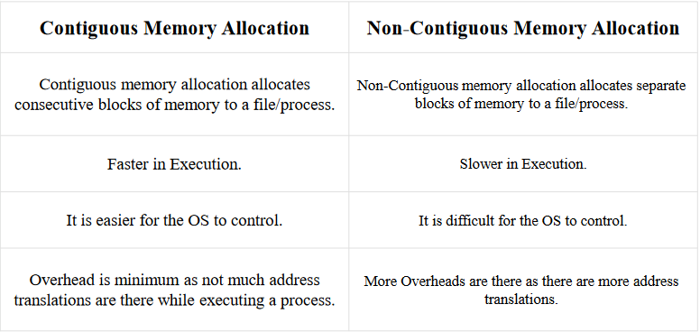
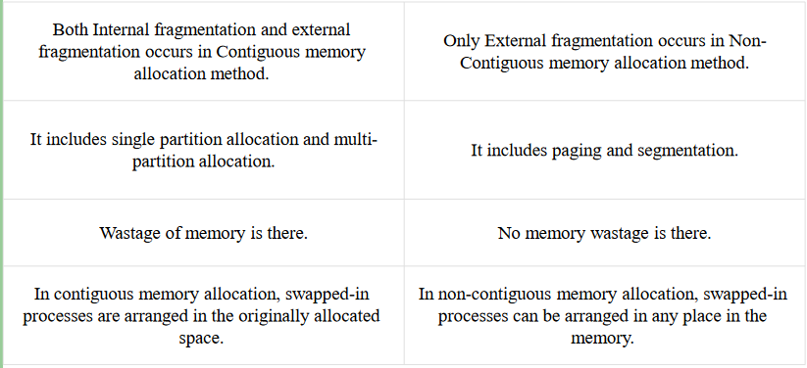
Q17. Explain Four Partition Management Techniques.
Ans. In operating systems, four common memory management techniques are:
- Single Contiguous Allocation: The simplest method where all memory (except for some reserved for the OS) is available to a single process.
- Partitioned Allocation: Memory is divided into blocks or partitions, with each process allocated according to its requirements.
- Paged Memory Management: Memory is divided into fixed-sized units called page frames, used in virtual memory environments.
- Segmented Memory Management: Memory is divided into segments, which represent logical groupings of a process's data or code. Allocated memory doesn’t need to be contiguous.
Most modern operating systems, like Windows and Linux, combine segmentation with paging, where a process is divided into segments, and each segment is further divided into pages.
Q18. What is Placement algorithms? Give some common placement algorithms.
Ans. Placement algorithms in memory management determine how processes and data are allocated in memory. Here are some common placement algorithms:
- First-Fit: This algorithm allocates the first available memory block that is large enough to accommodate the requested memory size. It scans the memory from the beginning and stops as soon as it finds a suitable block.
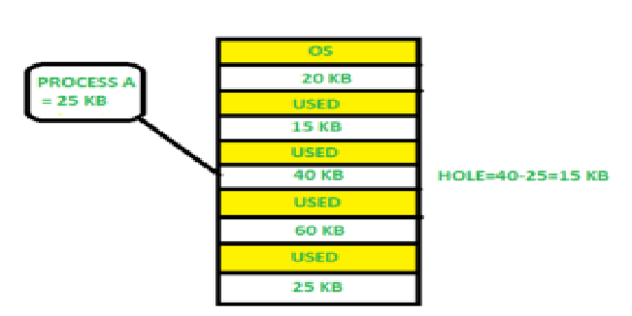

- Best-Fit: This algorithm searches the entire memory and allocates the smallest available block that is sufficient for the request. This approach minimizes wasted space but may lead to fragmentation over time.

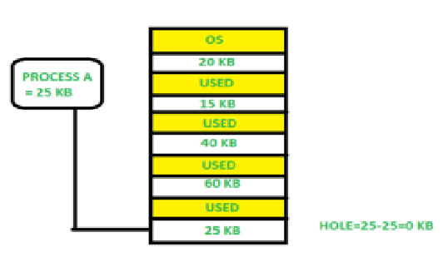

- Worst-Fit: This algorithm allocates the largest available memory block. The idea is to leave larger blocks free for future requests, potentially reducing fragmentation.
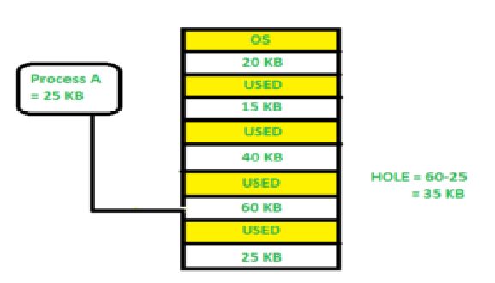

- Next-Fit: Similar to first-fit, but instead of starting from the beginning of the memory each time, it continues the search from the last allocated block. This can improve performance by avoiding scanning from the start repeatedly.
- Buddy System: Memory is divided into partitions that are powers of two. When a request is made, the system allocates the smallest block that fits the request. If the block is larger than needed, it can be split into smaller "buddy" blocks for future use.
Q19. What is Logical and Physical Address Space?
Ans. Logical and physical address spaces refer to two distinct views of memory in a computer system:
- Logical Address Space: This is the address space as seen by the program, which is generated by the CPU during program execution. It is an abstract view where the addresses are used by the program to access memory. The logical address space allows processes to be independent of the actual physical memory layout, providing an abstraction that enables features like memory protection and multitasking.
- Physical Address Space: This refers to the actual physical memory (RAM) locations in the computer system. It represents the real addresses used by the memory unit to access data. The physical address space is managed by the operating system and the memory management unit (MMU), which translates logical addresses generated by programs into physical addresses used in the hardware.
In summary, the logical address space is what programs use to reference memory, while the physical address space is the actual memory used by the hardware. The memory management unit handles the translation between the two to enable effective memory use and isolation between processes.
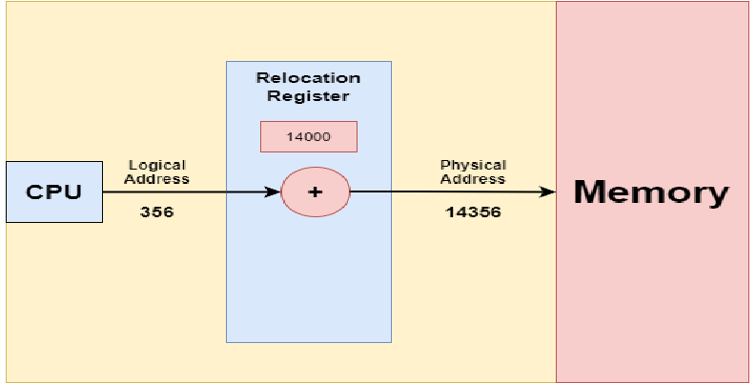
The base register has been renamed the relocation register. The value stored in the relocation register is added to every address generated by a user process when the address is sent to memory. For instance, if the base is set at 14,000, then an attempt by the user to access location 0 is dynamically relocated to location 14,000, while an access to location 346 is mapped to location 14,346.
Q20. What is Paging?
Ans. Paging is a memory management scheme that eliminates the need for contiguous physical memory allocation. It allows processes to be divided into fixed-size blocks called pages, which can be loaded into any available memory location. This approach facilitates efficient memory use by retrieving these pages from secondary storage into main memory as needed. The primary purpose of paging is to separate procedures into pages, making it easier to manage memory and reducing fragmentation.
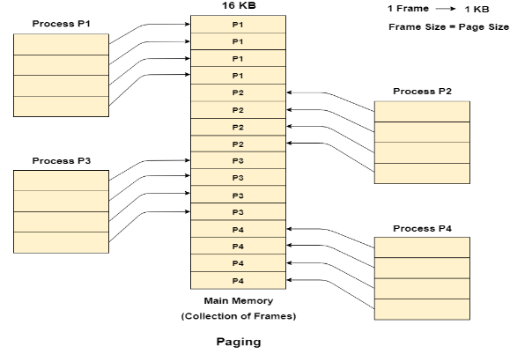
Q21 Write a short note on following:
a) Logical Address or Virtual Address
b) Logical Address Space or Virtual Address Space
c) Physical Address
d) Physical Address Space
Ans.
a) Logical Address or Virtual Address: A logical address, generated by the CPU, is used to access memory. It represents an abstract location in the logical address space rather than a physical memory location.
b) Logical Address Space or Virtual Address Space: This is the complete set of logical addresses generated by a program, typically represented in words or bytes and divided into fixed-size pages in a paging scheme.
c) Physical Address: A physical address corresponds to an actual location in memory. It is the address used by the memory controller to access data in RAM.
d) Physical Address Space: This is the total set of physical addresses that correspond to the logical addresses in the logical address space. It is usually represented in words or bytes and is divided into fixed-size frames in a paging scheme.
Q22. How are virtual to physical addresses converted?
Ans. The mapping from virtual to physical addresses is performed by the Memory Management Unit (MMU), a hardware device. This mapping process is known as the paging technique.
The Physical Address Space is divided into fixed-size blocks called frames, while the Logical Address Space is divided into blocks of the same size called pages. Therefore, the page size equals the frame size.
Q23. Explain Segmentation.
Ans. Segmentation is a memory management technique that divides a process into segments, which are variable-sized chunks representing different logical units, such as functions, arrays, or data structures. Unlike paging, segmentation provides a user-friendly view of the process, mapping logical segments to physical memory.
There are two types of segmentation in operating systems:
- Virtual Memory Segmentation: This method divides a process into segments that may not all be loaded into memory simultaneously. Segmentation can occur at runtime, allowing for more flexible memory use.
- Simple Segmentation: In this approach, all segments of a process are loaded into memory during runtime, though not necessarily contiguously. The relationship between logical and physical addresses is not straightforward, and a Segment Table maintains information about the segments, including their base addresses and lengths.
Q24. What is Segment Table?
Ans. The Segment Table is a data structure used in segmentation that maps a two-dimensional logical address (segment number and offset) into a one-dimensional physical address. Each entry in the Segment Table contains:
- Base Address: This indicates the starting physical address in memory where the segment is stored.
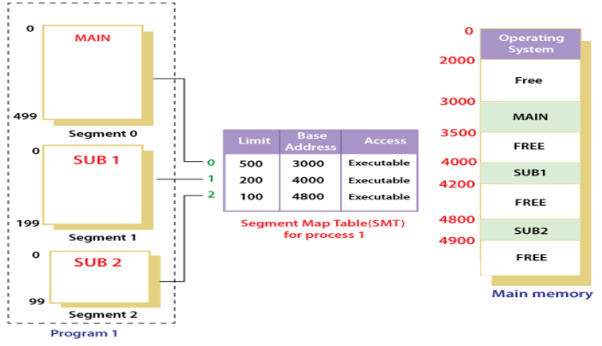
- Segment Limit: Also referred to as the segment offset, this specifies the length of the segment, ensuring that any access to the segment stays within its bounds.
Q25. What is Paged Segmentation?
Ans. Paged segmentation is a memory management technique that combines the concepts of paging and segmentation. In this scheme, a process is divided into segments, which are then further divided into fixed-size pages. This allows for more flexible memory allocation and efficient use of memory resources.
Key features of paged segmentation include:
- Segmentation: The process is divided into segments, each representing a logical unit such as a procedure or data structure. These segments can vary in size.
- Paging: Each segment is divided into fixed-size pages, allowing the system to manage memory in a more granular way. The size of the pages is typically uniform, making it easier to allocate and manage memory.
- Segment Table: Each segment has an associated segment table that contains the base address of the segment in physical memory and the segment limit.
- Page Table: Each segment also has a page table that maps the logical pages of that segment to physical frames in memory.
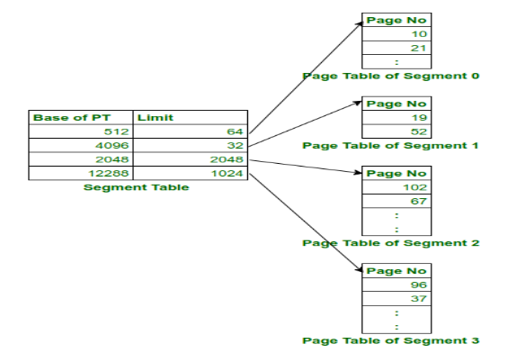

Q26. What is Segmented Paging?
Ans. Segmented paging is a memory management technique that combines segmentation and paging, providing a more flexible approach to memory allocation and management. In this system, a process is divided into segments, and each segment is further divided into fixed-size pages. This method helps to minimize fragmentation and allows for efficient use of memory.

Key Features of Segmented Paging:
- Segmentation: The process is divided into several segments, which can vary in size and represent different logical units, such as functions or data structures.
- Paging within Segments: Each segment is further divided into fixed-size pages. This allows for the benefits of paging, such as eliminating the need for contiguous memory allocation.
- Segment Table: There is a segment table for the process that contains the base address of each segment in physical memory and the limit (or size) of each segment.
- Page Table: Each segment has its own page table, which maps the logical pages of the segment to physical frames in memory. This means that the logical address consists of a segment number and a page number.
- Address Translation: The logical address is represented as a combination of the segment number, page number, and offset within the page. This address is translated by the Memory Management Unit (MMU) to retrieve the corresponding physical address.

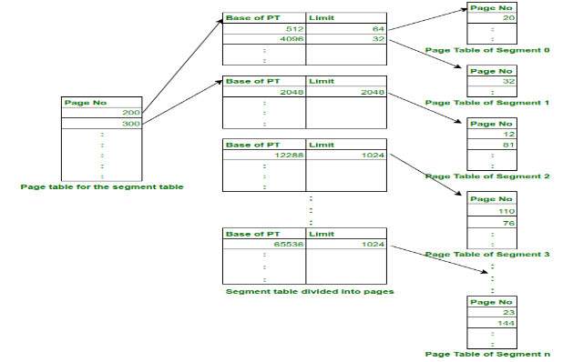
Q27. What is Demand paging?
Ans. Demand paging is a technique used in operating systems where pages are loaded from disk into main memory only when they are specifically needed by a program. This allows the operating system to conserve memory space by retaining only the pages that are currently required for execution.
In virtual memory systems, demand paging facilitates the loading of necessary pages at runtime rather than loading the entire program upfront. When a program tries to access a page that is not in memory, a page fault occurs. The operating system responds by loading the needed page from disk into memory, updating the page tables to reflect this change.
Q28. What Pure Demand Paging?
Ans. Pure demand paging is a refined implementation of demand paging where the operating system loads pages into memory exclusively when they are needed by a program. In this approach, no pages are preloaded into memory at the start of program execution. Instead, all pages are marked as being on disk initially.
Q29. What is a Page Fault?
Ans. A page fault occurs when the CPU tries to access a page not currently present in main memory, resulting in a miss. The system must retrieve the missing page from secondary memory. If the frequency of page faults is high, it can significantly increase the effective access time of the system.
Or
A page fault occurs when a program tries to access a memory page that is part of the virtual address space but is not currently loaded into physical memory. This situation arises because physical memory is limited compared to the potentially larger virtual memory. When a page fault happens, the operating system may need to replace one of the existing pages in memory with the required page. Different page replacement algorithms provide various strategies for selecting which page to replace, with the primary goal of minimizing the overall number of page faults.
Q30. What is Thrashing?
Ans. Thrashing occurs when the number of page faults equals the number of referred pages or when the page fault rate is so high that the CPU spends most of its time reading pages from secondary memory. This leads to a situation where the effective access time is dominated by the time it takes to read from secondary memory, resulting in very poor system performance.
Q31. Explain the working of demand paging.
Ans.
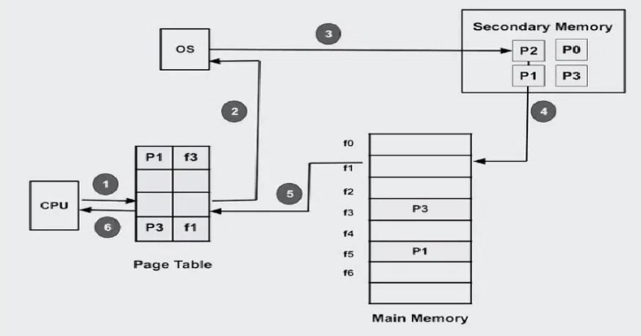
The working process of demand paging in an operating system involves several steps:
- Program Execution: When a program starts, the operating system creates a process for it and allocates memory for that process.
- Creating Page Tables: The operating system establishes page tables for the processes, which track which pages are currently in memory and which are stored on disk.
- Page Fault Handling: A page fault occurs when the program tries to access a page not in memory. The OS interrupts the program and checks the page tables to determine if the required page is on disk.
- Page Fetch: If the needed page is on disk, the OS fetches it and loads it into memory. The page table is then updated to reflect the new location of the page.
- Resuming the Program: Once the required pages are loaded, the OS resumes program execution from where it left off, as if the page had always been in memory.
- Page Replacement: If there is insufficient memory to hold all required pages, the OS may replace one or more pages currently in memory with those on disk. The page replacement algorithm determines which pages to replace.
- Page Cleanup: When a process terminates, the OS frees the memory allocated to that process and cleans up the corresponding entries in the page tables.
Q32. What is Page Replacement?
Ans. Page replacement is a process in an operating system where a page in main memory is swapped out and replaced with a page from secondary memory. This occurs when a requested page is not present in memory, and there are no free pages available for allocation.
Page replacement algorithms determine which pages to remove when a new page needs to be loaded into memory. These algorithms use limited information about page accesses to estimate which pages are least likely to be used again soon. The goal is to minimize the total number of page misses while balancing the algorithm's overhead.
The effectiveness of a page replacement algorithm is measured by the amount of time spent waiting for page transfers. A better algorithm minimizes this wait time, resulting in improved system performance.
Q33. Explain all types of replacement algorithm with example.
Ans.
1. First In First Out (FIFO): The First In First Out (FIFO) page replacement algorithm is indeed one of the simplest methods for managing pages in memory. FIFO maintains a queue of pages currently in memory, with the oldest page (the one that has been in memory the longest) at the front of the queue. When a new page needs to be loaded into memory and there is no free frame available, the oldest page is removed to make space for the new page.

• Example 1: Consider page reference string 1, 3, 0, 3, 5, 6,
3 with 3 page frames.Find the number of page faults.

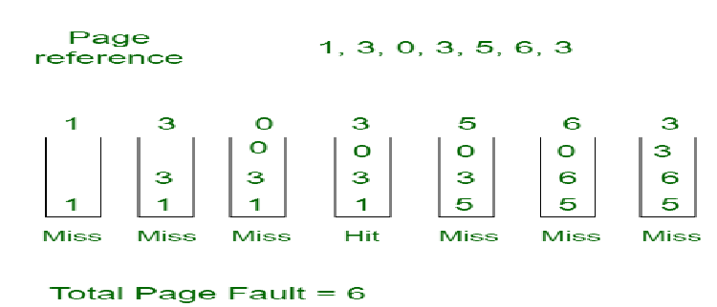

2. Optimal Page replacement: The Optimal Page Replacement algorithm is a theoretical page replacement strategy that aims to minimize the number of page faults by replacing the page that will not be used for the longest period in the future.

Example-2: Consider the page references 7, 0, 1, 2, 0, 3,
0, 4, 2, 3, 0, 3, 2, 3 with 4 page frame. Find number of
page fault.

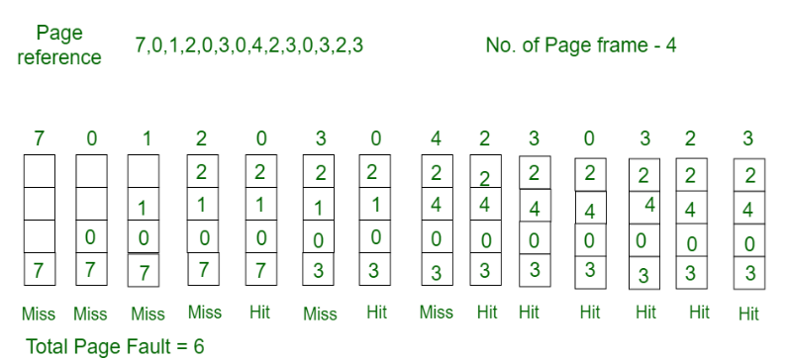
Least Recently Used: The LRU algorithm replaces the page that has not been used for the longest period of time. It assumes that pages used recently will be used again soon, while pages that haven't been used for a while are less likely to be used again.

Example-3: Consider the page reference string 7, 0, 1, 2,
0, 3, 0, 4, 2, 3, 0, 3, 2, 3 with 4 page frames. Find number
of page faults.
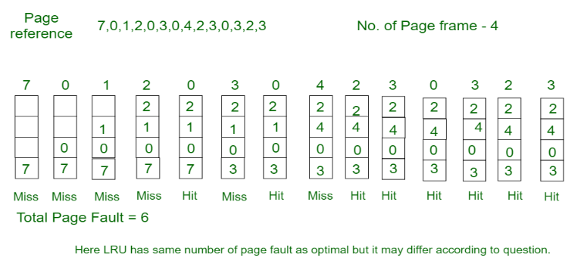
Q34. What will performance Demand Paging effect?
Ans. The performance of demand paging in operating systems is influenced by several critical factors:
- Page Size: The size of the pages can significantly impact performance. Larger page sizes may reduce the number of pages and page tables needed, which can lead to faster memory access. However, this can also result in increased internal fragmentation, wasting memory when the actual data does not fill the entire page.
- Page Replacement Algorithms: The efficiency of paging is heavily dependent on the page replacement algorithm implemented (e.g., FIFO, LRU, Optimal). The selected algorithm directly influences the page fault rate, determining how effectively the system can manage pages when memory is full. Poorly chosen algorithms can lead to increased page faults and reduced performance.
- Page Table Size: The size of the page table used for mapping virtual addresses to physical addresses affects overall memory access speed. A larger page table may introduce delays in accessing memory due to longer lookup times.
- Page Table Organization: The structure of the page table also impacts performance. Hierarchical or inverted page tables can help reduce the overall size of the page table, thus improving the speed of memory access and management.
- Page Fault Rate: A high page fault rate can severely degrade performance, as the operating system will spend more time handling page faults and swapping pages in and out of memory rather than executing processes. A lower page fault rate leads to smoother and faster execution.
- Thrashing: If the system experiences thrashing, where excessive page faults occur due to insufficient memory, performance drops significantly. The CPU may become underutilized, waiting for pages to load rather than executing instructions.

Q35. How can you measure Performance of Paging?
Ans. The performance of paging is crucial to evaluate, especially when considering the main memory access time, denoted as M. The effective memory access time (E.M.A.T) can be expressed as:
Effective Memory Access Time (E.M.A.T) = 2M
Key features influencing paging performance include:
- Translation Lookaside Buffer (TLB): A TLB is added to enhance performance and is implemented using associative registers.
- Access Time: TLB access time is significantly less than main memory access time.
- Contents: The TLB stores frequently accessed page numbers and their corresponding frame numbers.
For performance evaluation with TLB, let c be the TLB access time and x the TLB hit ratio. The E.M.A.T with TLB is given by:
E.M.A.T with TLB = x(c + M) + (1 - x)(c + 2M)
This formula accounts for TLB hits and misses, helping assess overall paging efficiency.
Q36. What is thrash and thrashing?
Ans. Thrash refers to the poor performance of a virtual memory system caused by repeatedly loading the same pages due to insufficient main memory.
Thrashing occurs when page faults and swapping happen at a high rate, leading the operating system to spend excessive time swapping pages instead of executing processes. This significantly reduces CPU utilization, as the CPU is unable to perform useful work. The core issue is that if a process is allocated too few frames, it results in frequent page faults, causing a drastic drop in CPU performance.

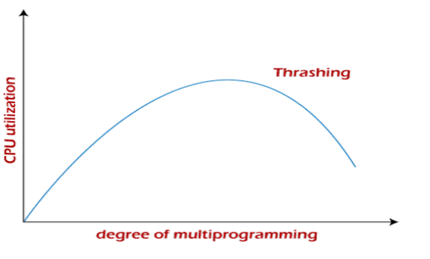

Q37. What are Techniques used to handle the thrashing?
Ans. Techniques Used to Handle Thrashing:
- Working Set: This technique identifies the set of pages in the most recent references, known as the working set. If a page is actively used, it remains in the working set; otherwise, it is removed. The working set approximates program locality and helps avoid thrashing while maintaining a high degree of multiprogramming.
- Page Fault Frequency (PFF): This technique focuses on monitoring and controlling the page fault rate to prevent thrashing. Unlike the working set model, which can be indirect, PFF provides a more straightforward approach to managing memory usage by adjusting the number of frames allocated to processes based on their page fault frequency.
Q38. What is demand segmentation?
Ans. Demand Segmentation is a memory management technique where a process is divided into segments of varying sizes. Each segment corresponds to a specific memory block. Unlike paging, where pages are loaded on demand, in segmentation, all segments are loaded during compilation. Demand segmentation combines aspects of both techniques, loading segments dynamically at runtime when required by the program, similar to how pages are loaded in demand paging.
Q39. What is Overlay Concepts?
Ans. Overlay Concepts in memory management refer to loading only the necessary parts of a program into memory while keeping other parts on disk or storage. This technique is useful when a program is larger than available memory. The idea is that since a process doesn’t use the entire program simultaneously, only the needed sections are loaded. Once a section is no longer required, it’s unloaded and replaced with the next required part. This allows efficient use of limited memory resources while running large programs.

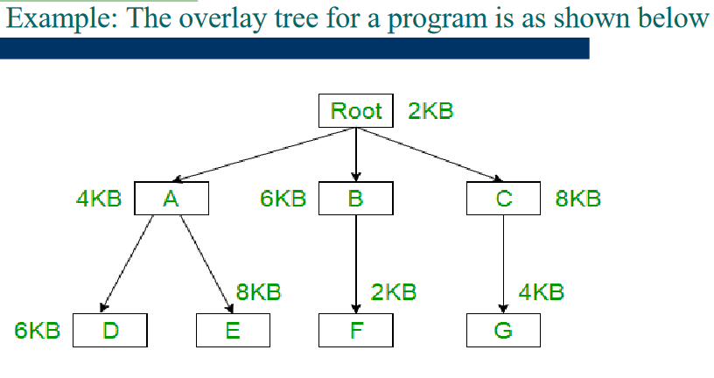
Q40. What are the advantage and disadvantages of using overlay concepts?
Ans. Advantages of using overlays:
- Increased memory utilization: Multiple programs can share memory space, improving efficiency.
- Reduced load time: Only essential program parts are loaded, speeding up performance.
- Improved reliability: Reduces the risk of memory overflow and crashes.
- Reduced memory requirement and time requirement.

Disadvantages of using overlays:
- Complexity: Implementing overlays is challenging, especially in large programs.
- Performance overhead: Frequent loading/unloading may increase CPU and disk usage, slowing performance.
- Compatibility issues: Overlays might not work on all hardware and software configurations.
- Manual mapping: The programmer must define memory requirements and ensure modules don't overlap.
Q41. Discuss Peterson‟s solution for the race condition with an algorithm.
Ans. Peterson's solution is a classic software-based algorithm for solving the critical section problem in concurrent programming, ensuring mutual exclusion and preventing race conditions between two processes. It uses two shared variables: flag and turn.
Algorithm:
flag[i] = True; // Express interest in entering critical section
turn = j; // Let the other process proceed if it wants to
while (flag[j] == True && turn == j); // Wait if the other process is interested and it's their turn
// Critical Section
flag[i] = False; // Exit the critical section
Q42. What is a monitor? Give the implementation of Bounded Buffer Producer Consumer
Problem using monitor.
Ans. A monitor is a synchronization construct in operating systems used to manage access to shared resources by multiple threads or processes. It provides a mechanism to allow only one thread to access the critical section at a time, ensuring mutual exclusion. Monitors simplify the synchronization process by combining mutual exclusion with the ability to block threads that cannot proceed, using condition variables.
The bounded buffer producer-consumer problem involves a buffer of fixed size shared between producer and consumer processes. The producer adds items to the buffer, and the consumer removes items from it. The problem is to ensure that:
- The producer waits if the buffer is full.
- The consumer waits if the buffer is empty.
Q43. Give the implementation of Readers-Writers Problem using Semaphore.
Ans. The Readers-Writers problem is a classical synchronization problem in operating systems. The problem arises when multiple processes (readers and writers) access a shared resource (e.g., a database). The key challenge is to allow multiple readers to read the resource simultaneously but ensure exclusive access for writers.

Semaphore-Based Solution:
In this solution, we use semaphores to control access to the shared resource.
- mutex: Ensures mutual exclusion when modifying the shared data (e.g., reader count).
- rw_mutex: Allows only one writer or multiple readers to access the resource simultaneously.
- read_count: Keeps track of how many readers are reading the resource.
Q44. Calculate the average amount of internal fragmentation paging scheme may sufferd) w.r.t to page size.
Ans. The average amount of internal fragmentation in a paging scheme can be calculated by considering the page size and the process size. Since pages are of fixed size, the last page of a process may not be fully utilized, leading to internal fragmentation.
For a given page size PPP, the average internal fragmentation can be calculated as follows:
- A process can leave between 0 and P−1 bytes unused in the last page.
- On average, the internal fragmentation will be half the page size, since the leftover space can be any value between 0 and P−1.
Thus, the average internal fragmentation is:
Average Internal Fragmentation=P/2, P is page file.
Q45. In a byte addressable system, the logical address space is of 24 bit where as
physical address space is 16 bit. The frame size is 1 KB and each entry in
page table requires 2 bytes. Find (i) No. of frames (i) No. of pages (ii) No.
of pages required to store the page table
Ans.
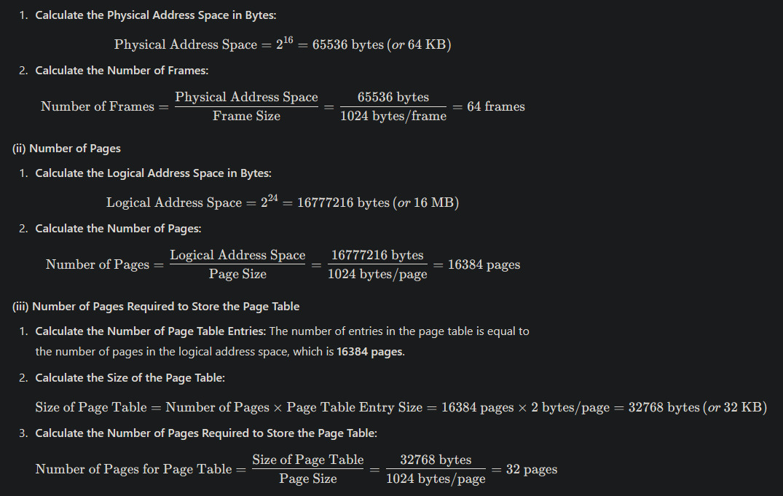
Q46. Define interrupts. Why interrupts are important for the functioning of the System.
Ans. Interrupts are signals sent to the CPU by hardware or software to indicate that an immediate attention or response is required. When an interrupt occurs, the CPU temporarily stops executing its current tasks, saves its state, and executes an interrupt handler to address the event.
Interrupts are important for the functioning of the system because they allow efficient management of resources and quick responses to critical events. Without interrupts, the CPU would need to constantly check (poll) devices and events, leading to inefficient use of processing power. By using interrupts, the system can:
- Respond to high-priority events immediately, like hardware failures or user inputs.
- Improve multitasking by managing processes and device communication effectively.
- Optimize CPU utilization by letting the CPU perform other tasks while waiting for events.
Q47. Define following (i) Context switching (ii) IPC
Ans. (i) Context Switching:
Context switching is the process of storing the state of a currently running process or thread so that it can be resumed later, and loading the state of a different process or thread to execute it. This involves saving the current process's context, including its program counter, registers, and memory maps, and restoring the context of the new process. Context switching enables multitasking in operating systems, allowing multiple processes to share the CPU effectively, although it can introduce overhead due to the time taken to save and load contexts.
(ii) IPC (Inter-Process Communication):
IPC refers to the methods and mechanisms that allow processes to communicate and synchronize their actions while executing concurrently. IPC is essential in operating systems to facilitate data exchange between processes, share resources, and coordinate execution. Common IPC mechanisms include pipes, message queues, shared memory, and semaphores. By using IPC, processes can collaborate and share information efficiently, enabling complex applications to function correctly in a multitasking environment.
Q48. What is Belady's anomaly?
Ans. Belady's anomaly refers to a counterintuitive phenomenon in page replacement algorithms where increasing the number of page frames allocated to a process can result in an increase in the number of page faults. This behavior contradicts the intuitive expectation that more frames should lead to fewer page faults.
Q49. What advantages is there in having different quantum size on different levels of multilevel queuing system?
Ans. Using different quantum sizes in a multilevel queuing system offers several advantages:
- Improved Responsiveness: Shorter quanta for interactive processes enhance user responsiveness by reducing wait times.
- Fairness: Different quanta ensure fair CPU time allocation among various process types.
- Optimal Resource Utilization: Tailoring quantum sizes to process types helps optimize CPU usage, minimizing context switching for compute-bound tasks while allowing quicker switches for I/O-bound ones.
- Reduced Overhead: Longer quanta for lower-priority tasks decrease context switching frequency, improving overall system efficiency.
- Adaptability: The system can dynamically adjust quantum sizes based on workload characteristics, enhancing performance for diverse tasks.
- Facilitated Prioritization: Different quanta inherently prioritize critical processes, improving responsiveness for essential tasks.
- Increased Throughput: Effective scheduling and management of different process types lead to better system throughput.

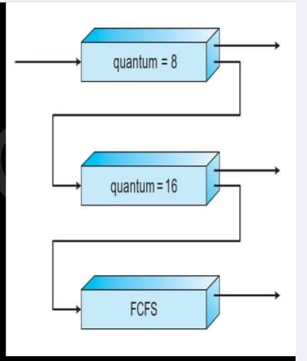
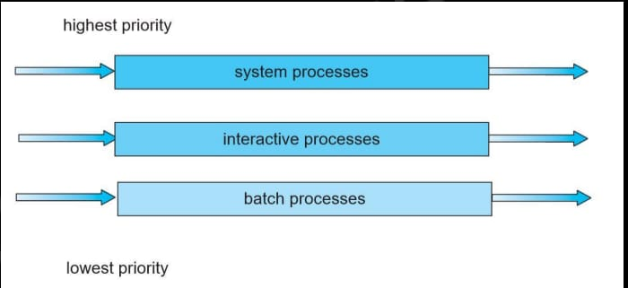

Q50. Explain Bakery algorithm.
Ans. The Bakery algorithm is a synchronization algorithm designed to solve the critical section problem in a concurrent system, particularly for ensuring mutual exclusion among multiple processes. Named after its similarity to a bakery where customers take a number and wait for their turn, this algorithm is particularly useful in scenarios with multiple threads or processes that need to access shared resources.
Q51. What is production consumer problem?
Ans. The Producer-Consumer problem is a classic synchronization problem in computer science that involves two types of processes: producers and consumers. The main challenge is to ensure that the producer does not add data into a full buffer and that the consumer does not attempt to remove data from an empty buffer. This problem is typically solved using synchronization mechanisms such as semaphores, mutexes, or monitors.
UNIT-3 OPERATING SYSTEM ALL QUESTIONS
Q1. What is Deadlock?
A process in operating system uses resources in the following way.
• Requests a resource
• Use the resource
• Releases the resource
A deadlock is a situation where a set of processes are blocked because each process is holding a resource and waiting for another resource acquired by some other process.
In an operating system, a deadlock occurs when a process or thread enters a waiting state because a requested system resource is held by another waiting process, which in turn is waiting for another resource held by another waiting process

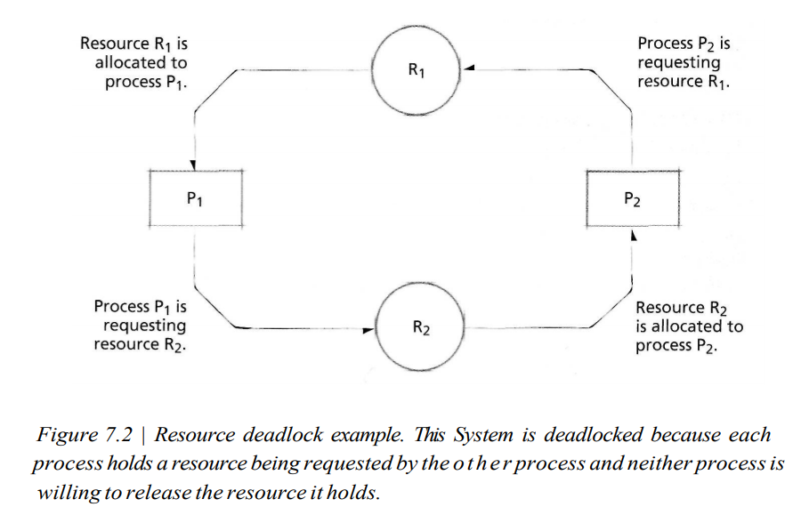

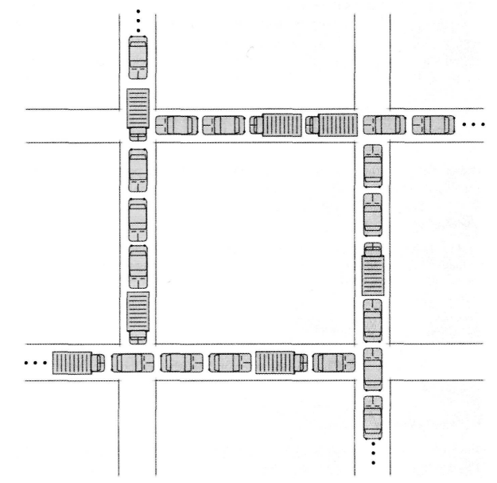
Q2. What are some examples of Deadlock?
- Traffic Deadlock: Cars stuck at an intersection with no vehicle able to move, requiring external intervention to resolve the jam.
- Simple Resource Deadlock: Processes holding resources and waiting for each other's resources indefinitely.
- Deadlock in Spooling Systems: Processes waiting for printer access when the spool is full.
- Dining Philosophers Problem: Philosophers competing for limited resources (forks), leading to indefinite waiting.

Q3. What is Indefinite Postponement?
Indefinite Postponement (or starvation) occurs when a process is repeatedly delayed from getting needed resources due to resource-allocation and scheduling decisions. This happens when higher-priority processes continue to take precedence, causing lower-priority processes to wait indefinitely. It is a serious issue similar to deadlock. To prevent this, systems may use aging, a method that increases a waiting process's priority over time, ensuring it eventually gets resources.
Q4. What are the different Resource Concepts?
The operating system acts as a resource manager, allocating various types of resources to processes. Resources can be categorized based on their properties:
- Preemptible Resources: These can be reassigned from one process to another without harm. Examples include processors and main memory. Preemption is critical in multiprogrammed systems to ensure efficient resource usage and process progression.
- Nonpreemptible Resources: These cannot be reassigned until voluntarily released by the process holding them. Examples include tape drives and optical scanners, often dedicated to a single process for extended periods.
- Shared vs. Dedicated Resources:
  - Shared Resources: Accessible by multiple processes, either simultaneously (e.g., reentrant code) or through multiplexing (e.g., processors, disks).
  - Dedicated Resources: Exclusively used by one process at a time, such as serially reusable code or certain hardware.
- Re-entrant and Serially Reusable Code:
  - Re-entrant Code: Shared among multiple processes without modification during execution.
  - Serially Reusable Code: Must be reinitialized before each use and can only be used by one process at a time, often leading to deadlock scenarios.
The operating system optimizes resource allocation to minimize redundancy (e.g., using shared code instead of redundant copies) and to prevent unpredictable behavior in processes. Proper handling of shared and serially reusable resources is crucial to avoid deadlocks and ensure system stability.
Q5. What are the four necessary conditions for deadlock?
1. A resource may be acquired exclusively by only one process at a time (mutual exclusion condition).
2. A process that has acquired an exclusive resource may hold that resource while the process waits to obtain other resources (wait-for condition, also called the hold-and-wait condition).
3. Once a process has obtained a resource, the system cannot remove it from the process's control until the process has finished using the resource (no-preemption condition).
4. Two or more processes are locked in a "circular chain" in which each process is waiting for one or more resources that the next process in the chair. is holding (circular-wait condition)

Because these are necessary conditions, the existence of a deadlock implies that each of them must be in effect.
Q6. What are solutions for Deadlock?
- Deadlock Prevention: Modify the system conditions to eliminate at least one of the necessary conditions for deadlock, ensuring that deadlocks cannot occur. However, this may lead to poor resource utilization.
- Deadlock Avoidance: Allow the possibility of deadlocks but carefully manage resource allocation to avoid them when they approach. This provides better resource utilization than prevention.
- Deadlock Detection: Actively monitor the system to detect deadlocks when they occur, identifying the processes and resources involved.
- Deadlock Recovery: Resolve deadlocks by terminating or restarting processes to free resources. This is often disruptive, with significant work lost for the affected processes.
Q7. Explain Deadlock Prevention in detail.
Deadlock prevention involves strategies to ensure that at least one of the four necessary conditions for deadlock is denied, thereby preventing its occurrence. Havender proposed three key strategies, which are explained below:
- Denying the "Wait-For" Condition:
Processes must request all required resources simultaneously. The system grants resources on an "all-or-none" basis. If all resources are available, they are allocated to the process; otherwise, the process waits without holding any resources. This eliminates the wait-for condition, thus preventing deadlock. However, this approach can lead to significant resource wastage as resources allocated to waiting processes may remain idle. To mitigate this, processes can be split into threads for better resource management, but this increases overhead. Additionally, prioritizing small requests over large ones can lead to indefinite postponement for processes with substantial needs.
- Denying the "No-Preemption" Condition:
If a process holding resources requests additional resources and the request cannot be fulfilled, it must release all its currently held resources. The process can then request all required resources again, including the additional ones. This denies the no-preemption condition since resources can be forcibly reallocated. While effective in preventing deadlock, this strategy can be costly due to frequent resource reallocation.
- Denying the "Circular-Wait" Condition:
Resources are assigned unique identifiers and arranged in a linear order. Processes must request resources in ascending order based on these identifiers. This prevents circular waiting by ensuring that a process cannot request a resource with a lower number after acquiring one with a higher number. However, determining an optimal order for resources can be challenging and may result in inefficient resource utilization if processes require resources in a different sequence.
While each strategy effectively prevents deadlock, they often come at the cost of resource utilization or system performance. The choice of strategy depends on the specific requirements and constraints of the system.
Q8. Explain Deadlock Avoidance with Dijkstra's Banker's Algorithm.
The Banker's Algorithm, proposed by Dijkstra, is a deadlock avoidance technique modeled after a banker allocating loans while ensuring all obligations can be met. It ensures safe resource allocation by assessing the system's state before granting resource requests. A system is considered "safe" if it can guarantee that all processes will complete within a finite time, regardless of the resource allocation sequence
The Banker's Algorithm, proposed by Edsger Dijkstra, is one of the most well-known deadlock avoidance algorithms. The algorithm is named after the analogy of a banker who manages a fixed amount of capital and grants loans based on certain safety criteria. In the context of operating systems, this algorithm is used to allocate resources in such a way that deadlock cannot occur.

Key Properties of the Banker's Algorithm
The Banker's Algorithm is designed to work under certain assumptions:
- Fixed number of resources: The system manages a fixed number of resources, and these resources are shared among multiple processes.
- Known maximum resource needs: Each process must declare the maximum number of resources it may need before it starts execution. This eliminates the possibility of a process suddenly requesting an unbounded number of resources.
- Resource allocation and process requests: The operating system accepts a resource request from a process if the requested resources do not exceed the total available resources in the system.
- Finite wait time: If a process cannot immediately obtain a resource, it will wait for a finite time before either completing its task or releasing its claim on resources.

Safe and Unsafe States
A system is in a safe state if the operating system can guarantee that every process can eventually obtain the resources it needs and complete its execution. In a safe state, there is no possibility of a deadlock occurring. In contrast, an unsafe state is a state where the system cannot guarantee the completion of all processes within a finite time, which could potentially lead to deadlock.

Terms Used in the Banker's Algorithm:
- max(Pi): The maximum number of resources that process Pi may need during its execution.
- loan(Pi): The current number of resources allocated to process Pi.
- claim(Pi): The number of resources process Pi still needs, which is calculated as max(Pi) - loan(Pi).
- available: The number of resources currently available in the system. This is equal to the total number of resources minus the sum of all loans to processes.

Resource Allocation Process:
The Banker's Algorithm works by checking if granting a resource request will lead to a safe or unsafe state. When a process requests resources, the system performs the following checks:
- Check if the request is valid: The requested resources must not exceed the maximum claim of the process or the available resources in the system.
- Simulate the allocation: Temporarily allocate the requested resources to the process and check if the system remains in a safe state. To do this, the system checks if there is a sequence of processes that can complete by continually allocating resources that become available as processes finish their execution.
- Check for safety: If there is a sequence that guarantees all processes can eventually finish, the system is in a safe state, and the request is granted. If no such sequence exists, the request is denied to prevent potential deadlock.

Example of a Safe State:
Consider a system with 12 resources and three processes. The table below shows the maximum resource needs, current loans, and claims for each process:
Process | max(Pi) | loan(Pi) | claim(Pi)
P1 | 5 | 2 | 3
P2 | 3 | 1 | 2
P3 | 4 | 3 | 1
The system has 12 total resources and 6 resources allocated. Therefore, the available resources are 12 - (2 + 1 + 3) = 6.
In this case, the system is in a safe state because, even though some resources are allocated to processes, there are enough resources available to ensure that all processes can eventually finish. For example, if process P1 completes, it releases its resources, and the remaining processes can continue to completion as well.

Example of an Unsafe State:
Consider the following scenario where the total resources are still 12, but the allocation table changes:
Process | max(Pi) | loan(Pi) | claim(Pi)
P1 | 5 | 3 | 2
P2 | 3 | 1 | 2
P3 | 4 | 3 | 1
Here, the available resources are 12 - (3 + 1 + 3) = 5. If process P1 requests and is granted the last available resource, the system might enter an unsafe state. Now, there aren't enough resources available to guarantee the completion of all processes, potentially resulting in a deadlock. For example, even if P1 finishes, processes P2 and P3 might still need resources that they cannot acquire, leading to a circular wait.

Advantages of the Banker's Algorithm:
- Prevents deadlock: By ensuring that the system only enters safe states, the Banker's Algorithm effectively prevents deadlock.
- Efficient resource allocation: The algorithm helps ensure that resources are allocated in a way that maximizes system throughput and prevents resource starvation.
- Flexible: While this example considers only one resource type, the algorithm can be extended to handle multiple types of resources.
Q9. How Banker's Algorithm Resource Allocation is done?
In the Banker's Algorithm for resource allocation, processes request resources one at a time, and the system either grants or denies each request based on whether it would lead to a safe state. If a request would cause an unsafe state, it is denied, and the process holds any already allocated resources while waiting for the request to be granted. The system ensures that resources are only allocated when doing so does not lead to a deadlock, maintaining a safe state at all times. As a result, all requests will eventually be satisfied, and all processes will eventually complete.
Q10. What are the Weaknesses in the Banker's Algorithm?
The Banker's Algorithm, while useful, has several weaknesses:
- It requires a fixed number of resources, which is unrealistic in systems where resources can be dynamically added or removed (e.g., due to breakdowns or hot-swappable devices).
- It assumes a fixed process population, which is not feasible in modern interactive and multiprogrammed systems where processes can constantly change.
- The algorithm demands that all resource requests and repayments occur within a finite time, which is impractical, especially for real-time systems.
- It requires processes to declare their maximum resource needs in advance, which is increasingly difficult in dynamic environments where resource requirements are not predictable.
- Due to these constraints, the Banker's Algorithm is not widely used in modern operating systems, as the overhead involved in deadlock avoidance strategies makes it less practical.
Q11. Explain Deadlock Detection.
Deadlock detection involves identifying the presence of a deadlock and pinpointing the processes and resources involved. Detection typically centres on checking for circular waits in systems where the other necessary deadlock conditions—mutual exclusion, hold and wait, and no preemption—exist.
Resource-Allocation Graphs are a key tool for visualizing and detecting deadlocks. These graphs use directed edges to represent resource allocations and requests. Processes are depicted as squares, resource types as large circles, and individual resources within a type as small circles inside the larger circle.
Graph Reduction Technique is a systematic method used in deadlock detection:
- If a process’s resource requests can be fully satisfied, it is allowed to complete, and its allocated resources are released back to the system.
- The graph is updated by removing all edges associated with the completed process.
- This process continues iteratively.
- If all processes can complete, no deadlock exists. However, if some processes remain irreducible, they form the set of deadlocked processes, along with the resources involved.
Deadlock detection algorithms, while effective, can be computationally expensive, and their utility must be weighed against the system's performance requirements.

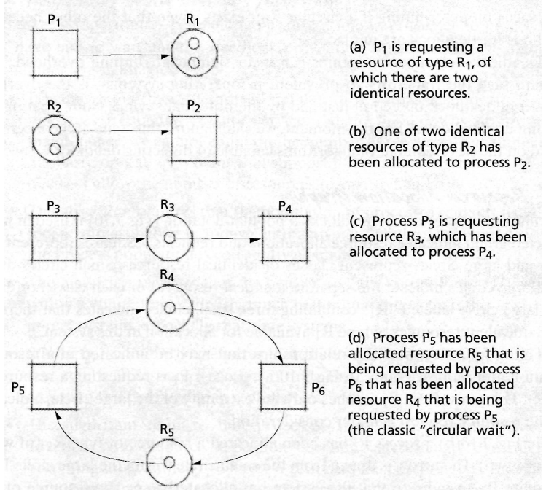

Q12. Explain Deadlock Recovery in detail.
Deadlock recovery involves breaking a deadlock once it has occurred, usually by disrupting one or more of the conditions necessary for deadlock. This often results in some processes losing their progress but ensures that the system can resume normal operation.
The main challenges in deadlock recovery are:
- Identifying Deadlocks: It can be difficult to confirm if the system is deadlocked, especially with periodic processes that operate intermittently or real-time processes that cannot easily be paused or resumed.
- Suspension and Resumption: Many systems lack robust suspend/resume mechanisms. Implementing these would introduce overhead and require skilled administration, which may not always be feasible.
- Process Termination: Recovery often involves forcibly terminating one or more processes to reclaim resources. This approach can result in the loss of work and is especially complex when multiple processes are involved.
- Priority Conflicts: Choosing which process to terminate is challenging. If priorities are absent or unclear, decisions may be arbitrary and not optimal. Temporary priorities, such as those due to deadlines, add further complications.
Methods for recovery include:
- Process Termination: Selectively terminate one or more processes involved in the deadlock, either based on priorities or arbitrarily, until the deadlock is resolved.
- Resource Preemption: Temporarily reclaim resources from processes and reallocate them, often using checkpoint/rollback mechanisms to minimize work loss.
Suspend/Resume Mechanisms allow processes to be paused, their state saved, and later resumed without loss of work. These mechanisms are also useful in power management (e.g., "hibernate" in Windows systems) and rely on technologies like ACPI to save system states.
Checkpoint/Rollback strategies help mitigate work loss by saving system states periodically. If a process is terminated, the system rolls back operations to the last checkpoint, ensuring data consistency, especially in database systems where transactions manage resource allocations.
In critical real-time systems, deadlocks can have catastrophic consequences, making instantaneous detection and recovery essential. However, the complexity of such scenarios poses significant challenges for operating system designers.
Q13. What is Disk Scheduling? Why is it Necessary?
Disk scheduling is the process of managing and optimizing the order in which disk I/O requests are handled. It is necessary because multiple processes often generate simultaneous requests for disk operations, creating queues that need to be managed efficiently to ensure optimal system performance.
When disk requests are processed sequentially in a First-Come-First-Served (FCFS) manner, the seek pattern becomes random. This can lead to excessive mechanical movement of the disk's read/write head, especially when switching between widely separated tracks, resulting in significant delays under heavy loads. Disk scheduling helps reduce these delays by reordering requests to minimize the total seek time or rotational latency.
The need for disk scheduling arises due to the following reasons:
- Concurrency: Multiple processes competing for disk access.
- Inefficiency of FCFS: High seek times and longer waiting periods in random access patterns.
- System Performance: Reordering requests improves throughput and reduces the average response time.
Most disk scheduling algorithms focus on seek optimization since seek time (the time to position the read/write head) is a dominant factor in disk performance. However, with the reduction in the gap between seek time and rotational latency, some algorithms also consider rotational optimization, focusing on minimizing latency under high loads.

Q14. What are Disk Scheduling Strategies? Explain all in detail.
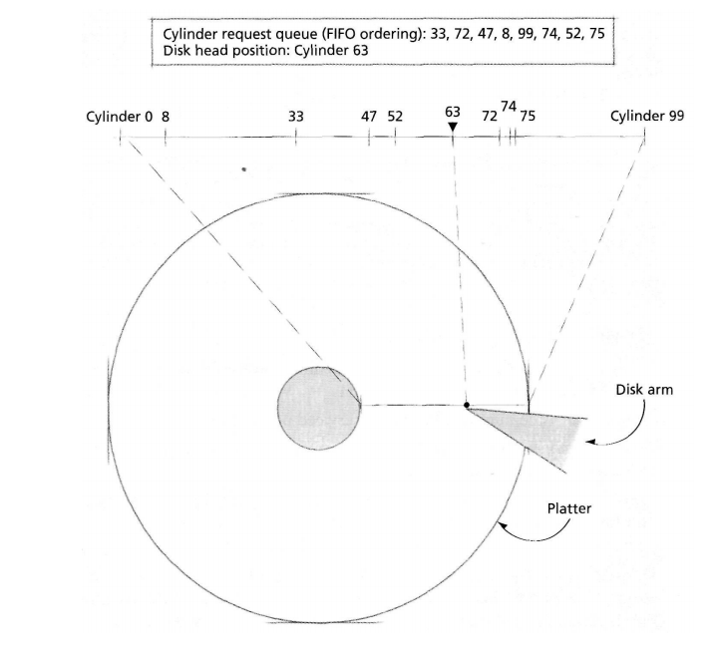

Disk Scheduling Strategies
Disk scheduling strategies aim to optimize the servicing of disk I/O requests by minimizing seek time, rotational latency, and overall response times. Each strategy has unique characteristics suited to specific workloads and system requirements. Below is a detailed explanation of commonly used disk scheduling strategies:

1. First-Come-First-Served (FCFS)
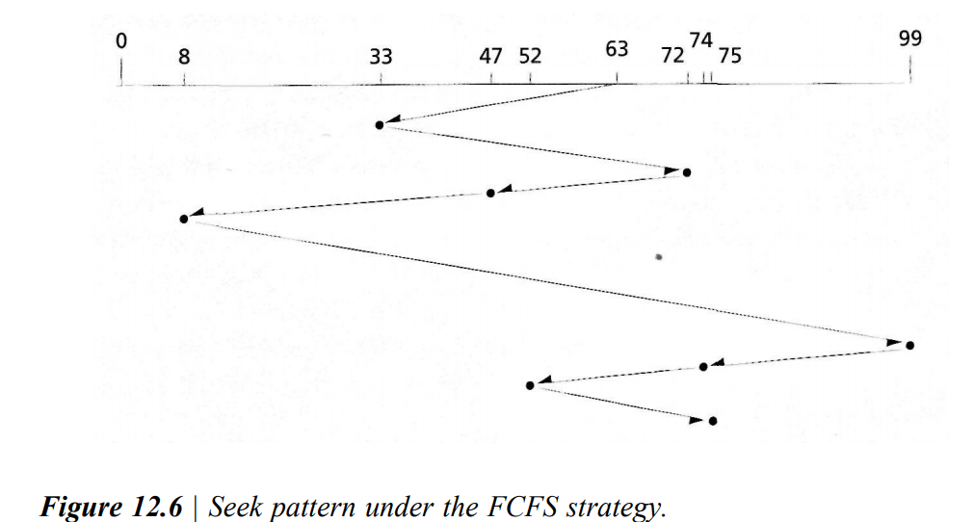

- Mechanism: Requests are processed in the order they arrive.

- Advantages:
  - Simple and fair, ensuring no request is indefinitely delayed.
  - Low computational overhead.
- Disadvantages:
  - Results in high seek times due to random access patterns.
  - Inefficient under heavy loads, leading to poor throughput and long response times.
- Use Case: Light workloads with fewer disk requests.

2. Shortest-Seek-Time-First (SSTF)
- Mechanism: Services the request closest to the current head position, minimizing seek time.
- Advantages:
  - Reduces average seek times, increasing throughput.
  - Provides lower mean response times compared to FCFS under moderate loads.
- Disadvantages:
  - Can cause starvation of requests far from the head due to localized seek patterns.
  - Higher variance in response times.
- Use Case: Moderate loads with a focus on throughput over fairness.

3. SCAN (Elevator Algorithm)
- Mechanism: Moves the head in one direction, servicing all requests along the path, then reverses direction.
- Advantages:
  - Provides better fairness compared to SSTF.
  - Reduces variance in response times.
  - Balances throughput and response time.
- Disadvantages:
  - Requests near the ends of the disk may experience longer delays.
- Use Case: Systems requiring predictable response times and balanced performance.

4. Circular SCAN (C-SCAN)
- Mechanism: Moves the head in one direction (e.g., outward), servicing requests, then jumps back to the start without servicing any requests in the return path.
- Advantages:
  - Prevents starvation and ensures uniform wait times for all cylinders.
  - Limits bias against outermost and innermost cylinders.
- Disadvantages:
  - Slightly lower throughput compared to SCAN due to the unserviced return path.
- Use Case: Systems needing uniform response times across all disk regions.

5. LOOK
- Mechanism: Similar to SCAN, but reverses direction when there are no more requests in the current sweep direction, avoiding unnecessary movement.
- Advantages:
  - Reduces unnecessary seeks, improving performance.
  - Offers a balanced approach to fairness and efficiency.
- Disadvantages:
  - May still exhibit higher variance in response times for extreme cylinder positions.
- Use Case: Systems prioritizing efficiency in seek operations.

6. Circular LOOK (C-LOOK)
- Mechanism: Like LOOK, but jumps to the closest pending request on the opposite end instead of reversing direction.
- Advantages:
  - Avoids unnecessary traversal of unrequested areas.
  - Balances throughput and fairness more effectively than LOOK.
- Disadvantages:
  - Slightly lower throughput compared to SCAN for some workloads.
- Use Case: Systems needing fairness and reduced response time variance.

7. FSCAN
- Mechanism: Freezes the queue at the start of a sweep, servicing only the requests present at that time. New requests are queued for the next sweep.
- Advantages:
  - Prevents starvation by ensuring all queued requests are serviced.
  - Maintains fairness while optimizing seek times.
- Disadvantages:
  - Performance depends on the size and distribution of queued requests.
- Use Case: Workloads with sporadic request arrivals.

8. N-Step SCAN
- Mechanism: Divides requests into groups of n, processes them using SCAN, and queues new requests for subsequent sweeps.
- Advantages:
  - Tunable for specific workloads by adjusting n.
  - Reduces delays and improves predictability.
- Disadvantages:
  - High values of n reduce benefits, approximating SCAN.
- Use Case: Systems requiring controlled batching of requests.

Evaluation Criteria
- Throughput: The number of requests serviced per unit of time.
- Mean Response Time: Average wait time for a request.
- Variance of Response Times: Predictability and fairness in servicing requests.
Each strategy's effectiveness depends on system objectives, workload patterns, and the need for fairness or efficiency.

Examples for Disk Scheduling Strategies
Below are examples for each disk scheduling strategy. Assume the disk has cylinders numbered 0 to 199 and the current position of the read/write head is at cylinder 50. The queue of pending requests is as follows:
Requests: 95, 180, 34, 119, 11, 123, 62.

1. First-Come-First-Served (FCFS)
Order of processing: 95 → 180 → 34 → 119 → 11 → 123 → 62
Head movement:
- 50 → 95 → 180 → 34 → 119 → 11 → 123 → 62
- Total Head Movement: |95-50| + |180-95| + |34-180| + |119-34| + |11-119| + |123-11| + |62-123| = 640 cylinders

2. Shortest-Seek-Time-First (SSTF)
Order of processing: 62 → 95 → 119 → 123 → 180 → 34 → 11
Head movement:
- Start at 50. Closest request is 62.
- 50 → 62 → 95 → 119 → 123 → 180 → 34 → 11
- Total Head Movement: |62-50| + |95-62| + |119-95| + |123-119| + |180-123| + |34-180| + |11-34| = 236 cylinders

3. SCAN (Elevator Algorithm)
Direction: Moving outward (increasing cylinders) first, then inward.
Order of processing: 62 → 95 → 119 → 123 → 180 → 199 (max) → 34 → 11
Head movement:
- 50 → 62 → 95 → 119 → 123 → 180 → 199 → 34 → 11
- Total Head Movement: |62-50| + |95-62| + |119-95| + |123-119| + |180-123| + |199-180| + |199-34| + |34-11| = 384 cylinders

4. Circular SCAN (C-SCAN)
Direction: Always moves outward and jumps to the lowest cylinder when reaching the highest.
Order of processing: 62 → 95 → 119 → 123 → 180 → 199 (max) → 0 (jump) → 11 → 34
Head movement:
- 50 → 62 → 95 → 119 → 123 → 180 → 199 → 0 → 11 → 34
- Total Head Movement: |62-50| + |95-62| + |119-95| + |123-119| + |180-123| + |199-180| + |199-0| + |11-0| + |34-11| = 408 cylinders

5. LOOK
Direction: Moves outward, reverses when no more requests in that direction.
Order of processing: 62 → 95 → 119 → 123 → 180 → 34 → 11
Head movement:
- 50 → 62 → 95 → 119 → 123 → 180 → 34 → 11
- Total Head Movement: |62-50| + |95-62| + |119-95| + |123-119| + |180-123| + |34-180| + |11-34| = 318 cylinders

6. Circular LOOK (C-LOOK)
Direction: Moves outward, jumps to the lowest request without servicing in between.
Order of processing: 62 → 95 → 119 → 123 → 180 → 11 → 34
Head movement:
- 50 → 62 → 95 → 119 → 123 → 180 → 11 → 34
- Total Head Movement: |62-50| + |95-62| + |119-95| + |123-119| + |180-123| + |11-180| + |34-11| = 310 cylinders

7. FSCAN
Scenario: Assume requests are divided into two sweeps.
- Sweep 1: 62, 95, 119, 123
- Sweep 2: 180, 34, 11
Order of processing:
- Sweep 1: 62 → 95 → 119 → 123
- Sweep 2: 11 → 34 → 180
Head movement:
- Sweep 1: 50 → 62 → 95 → 119 → 123
- Sweep 2: 123 → 11 → 34 → 180
- Total Head Movement: |62-50| + |95-62| + |119-95| + |123-119| + |123-11| + |34-11| + |180-34| = 314 cylinders

8. N-Step SCAN
Scenario: Divide into groups of n = 3 requests.
- Group 1: 62, 95, 119
- Group 2: 123, 180, 11
- Order of processing:
  - Group 1: 62 → 95 → 119
  - Group 2: 11 → 123 → 180
Head movement:
- Group 1: 50 → 62 → 95 → 119
- Group 2: 119 → 11 → 123 → 180
- Total Head Movement: |62-50| + |95-62| + |119-95| + |119-11| + |123-11| + |180-123| = 277 cylinders
These examples highlight the unique behavior and performance trade-offs of each strategy.
Q15. What is Rotational Optimization? Explain.

Rotational Optimization
Rotational optimization focuses on minimizing the time spent waiting for the disk platter to rotate to the desired sector. Unlike traditional seek optimization, which reduces the time required to move the disk arm to the correct cylinder, rotational optimization becomes crucial when seek times and rotational latencies are of similar magnitude. It is especially beneficial when handling small, randomly distributed requests, as opposed to sequential access patterns where data is read from entire tracks.

Key Strategies for Rotational Optimization
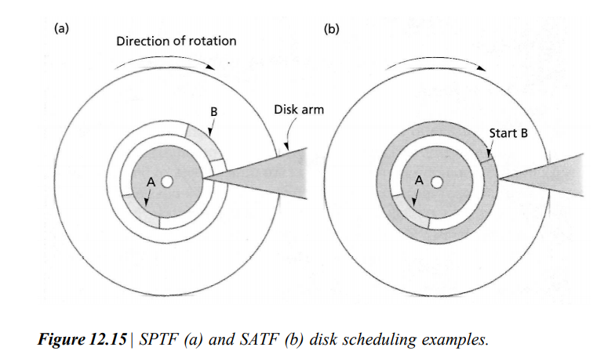

- Shortest-Latency-Time-First (SLTF):
This strategy prioritizes servicing the request on the current cylinder with the shortest rotational delay. By evaluating pending requests within the same cylinder, SLTF minimizes rotational latency, making it efficient for random access patterns. This method is straightforward and approaches the theoretical optimal performance.
- Shortest-Positioning-Time-First (SPTF):
SPTF selects the request requiring the shortest total positioning time, which includes seek time and rotational latency. This strategy balances both seek and rotational delays, enhancing throughput and reducing response time. However, it risks starvation of requests on the outermost or innermost cylinders due to continuous midrange request prioritization.
- Shortest-Access-Time-First (SATF):
SATF extends SPTF by incorporating transmission time into its calculations. This strategy prioritizes the request with the shortest overall access time, which includes positioning and data transfer time. While SATF maximizes throughput, it may indefinitely delay large or edge-cylinder requests due to frequent small or mid-cylinder requests.

Example Illustration
Consider two requests:
- Request A: Data located on the current cylinder but requires half a platter rotation (180°) to reach.
- Request B: Data located on an adjacent cylinder but near the current read/write head.
- SLTF: Services A first, minimizing rotational latency.
- SPTF and SATF: Services B first, as the single-cylinder seek is faster than half a platter rotation. Both strategies allow servicing B and repositioning for A within one rotation, achieving higher throughput than SLTF.

Benefits of Rotational Optimization
- Improves performance for random access patterns.
- Increases throughput by minimizing combined seek and rotational delays.
- Optimizes access for applications with mixed data distribution.
Rotational optimization strategies like SLTF, SPTF, and SATF can significantly improve disk performance when implemented alongside seek optimization techniques.

Q16. What are the system considerations for Disk Scheduling?

System Considerations for Disk Scheduling
Disk scheduling's usefulness and potential to degrade performance depend on several system-level factors, including the workload, system load, and file organization techniques.
When Disk Scheduling is Useful:
- Storage as a Bottleneck:
When disk storage becomes a limiting resource due to high request loads on a small number of disks, scheduling algorithms can alleviate the bottleneck by optimizing the order of requests. This ensures efficient utilization of disk resources and reduces delays.
- High System Load:
In systems with a high degree of multiprogramming or erratic request patterns, such as file servers or online transaction processing (OLTP) systems, disk scheduling becomes crucial. Algorithms like C-LOOK and SATF can improve performance by handling randomly distributed small data requests efficiently.
- Random Request Patterns:
Disk scheduling is particularly effective in environments where requests are distributed non-sequentially over the disk, as in web servers or database systems. This randomness benefits from optimization strategies that minimize seek time and rotational delay.
When Disk Scheduling Might Degrade Performance:
- Low System Load:
In batch-processing systems with minimal multiprogramming, disk scheduling may add unnecessary complexity without significant performance gains. Sequential or predictable access patterns are already efficient without additional scheduling.
- Non-Uniform Request Distribution:
Many disk references tend to target the same cylinder as the preceding request, leading to non-uniform access patterns. Scheduling algorithms designed under the assumption of uniform distributions may perform poorly in such cases, resulting in inefficiencies.
- Complex File Organization Techniques:
Sophisticated file structures requiring multiple seeks (e.g., referencing master and cylinder indexes) can increase seek times. These techniques, while convenient for application developers, can cause excessive delays, negating the benefits of disk scheduling.

Q17. Explain Caching and Buffering in detail.
Caching and buffering are essential techniques used in operating systems to improve disk I/O performance by reducing access time and optimizing the handling of data transfers.
Caching refers to storing frequently accessed data in a high-speed storage area (e.g., main memory) to avoid repeatedly fetching it from slower storage like a disk. The main goals of caching are to reduce access latency and increase overall system efficiency. A disk cache buffer serves as a temporary storage area for data recently read from or written to disk.
- Replacement Strategies:
Since cache size is limited, operating systems implement replacement strategies, such as Least Recently Used (LRU), to decide which data to evict when new data needs to be loaded into the cache.
- Write Policies:
  - Write-Back Caching: Data is written to the cache first and only periodically flushed to the disk. This approach improves performance by allowing batch processing of multiple write requests but risks data loss during crashes.
  - Write-Through Caching: Data is written both to the cache and the disk simultaneously. Although safer, this method can reduce performance by not leveraging batching.

- Challenges:
  - Inconsistency Risks: Since the cache resides in volatile memory, power failures or crashes can result in data loss. Periodic flushing of cache contents to disk helps mitigate this issue.
  - Duplicate Data: On-board caches in hard drives can duplicate data stored in the main memory buffer cache, leading to inefficient use of resources.
Buffering refers to the temporary storage of data during I/O operations to smooth out discrepancies between the speed of the disk and the CPU or memory. It acts as an intermediary to ensure efficient data transfer.
- Write Buffering:
Delays writing data to disk until the disk load is lower or the disk head is in an optimal position. This reduces the mechanical delays associated with disk I/O and allows multiple contiguous writes to be handled in a single operation.
- Read Buffering:
Stores data in anticipation of future requests, allowing faster access to sequential data without requiring additional disk operations.
- On-Board Buffering:
Modern hard drives have their own high-speed buffer caches, enabling faster delivery of requested data without mechanical delays. These are especially useful when the main memory buffer cache misses.
- Challenges:
  - Random Requests: On-board buffers may not adapt well to non-sequential access patterns, leading to inefficiencies.
  - Synchronization: Managing multiple buffer layers (e.g., main memory, on-board cache) requires careful coordination to prevent inefficiencies.
In summary, caching focuses on speeding up repetitive access by temporarily storing frequently used data, while buffering ensures efficient and optimized data transfer between devices. While both techniques enhance system performance, their design and implementation involve trade-offs between speed, resource utilization, and data safety.

Q18. What are Disk Performance Techniques?
Optimizing disk performance involves various strategies to improve data access efficiency and reduce latency in storage devices.
- Defragmentation:
Disk fragmentation scatters file data across the disk, increasing access times. Defragmentation reorganizes files so that their records are stored contiguously, reducing seek times and improving performance for sequential files.
- Placement Strategies:
Frequently accessed data can be placed on midrange cylinders, as they are often visited more frequently, minimizing average access time. Files prone to modification are placed near free space to reduce fragmentation caused by growth.
- Disk Partitioning:
Partitioning divides a disk into separate sections, restricting files to specific areas, which reduces fragmentation. However, it may lead to wasted space, similar to internal fragmentation in memory systems.
- Data Compression:
Compression reduces the storage space needed by replacing common patterns with shorter representations. This decreases seek and latency times but requires additional processing for compression and decompression.
- Redundancy:
Frequently accessed data may be duplicated in different disk locations, reducing seek and rotation times. This method is efficient for read-only or rarely updated data, but maintaining consistency during updates can be challenging.
- Record Blocking:
Combining contiguous records into a single block minimizes seeks by processing them in one operation. This improves throughput compared to reading or writing records individually.
- Disk Arm Anticipation:
Positioning the disk arm in anticipation of the next access request (e.g., near the center or a hotspot of activity) reduces average seek time, especially in high-access scenarios.
Q19. What is RAID (Redundant Arrays of Independent Disks)?
RAID is a system of organizing multiple disks to improve performance, reliability, or both. It was introduced by Patterson, Gibson, and Katz to address the growing disparity between processor speeds and I/O transfer rates.
- Key Features:
  - Combines multiple disks into an array to distribute data and workloads.
  - Allows simultaneous access to disks, increasing throughput and data transfer rates.
  - Enhances reliability by using redundancy to prevent data loss in case of disk failures.
- Original Purpose:
Initially proposed as a cost-effective way to use inexpensive disks ("Inexpensive" in RAID), the term evolved to "Independent," reflecting the modern use of high-performance disks.
- Advantages:
  - Performance: Parallel access to disks boosts read and write speeds.
  - Reliability: Redundancy schemes protect against hardware failures.
RAID configurations vary based on levels, each offering different trade-offs between performance, fault tolerance, and storage efficiency.
UNIT-4 OPERATING SYSTEM ALL QUESTIONS
Q1. What is File System? What are the common types of file systems?
A file system is a method used by an operating system to store, organize, retrieve, and manage files and directories on storage devices. It defines how data is structured and accessed on the device, ensuring efficient and secure data management.
Common Types of File Systems:
- FAT (File Allocation Table):
In this technique, the operating system uses a file allocation table to keep track of the location of each file on the disk. When a file is created, the operating system updates the file allocation table with the address of the disk blocks that make up the file. This method is widely used in Microsoft Windows operating systems.
  - An older file system used in legacy Windows systems and portable devices.
  - Simple but lacks advanced features like permissions and security.
- NTFS (New Technology File System):
  - The primary file system for Windows.
  - Supports features such as access control, encryption, journaling, and large file sizes.
- ext (Extended File System):
  - Used in Linux and Unix-based systems (e.g., ext2, ext3, ext4).
  - Ext4 is the most common, offering improved performance and support for large files.
- HFS (Hierarchical File System):
  - Previously used by macOS for organizing data.
  - Offers features like file metadata and journaling.
- APFS (Apple File System):
  - A modern file system for macOS and iOS.
  - Designed for SSDs, with features like encryption, snapshots, and fast directory sizing.
Q2. What is File Organization?
File organization refers to the way records in a file are arranged on secondary storage to facilitate efficient access and management. Different file organization schemes suit varying access patterns and applications:
- Sequential Organization:
  - Records are stored in a specific physical order.
  - The "next" record is physically adjacent to the previous one.
  - Common in magnetic tapes and sometimes on disks. Not all records are necessarily stored contiguously on disks.
- Direct Organization:
  - Records are accessed directly using their physical addresses.
  - Suitable for Direct Access Storage Devices (DASD).
  - Allows random access to records based on application needs.
- Indexed Sequential Organization:
  - Records are logically ordered by a key field.
  - An index is maintained, mapping key values to physical record addresses.
  - Supports sequential access by key order and direct access via index lookups.
- Partitioned Organization:
  - The file is divided into sequential subfiles called "members."
  - A directory holds the starting addresses of each member.
  - Commonly used for program and macro libraries.
Q3. What are the issues handled by the File System?
The file system manages several critical issues to ensure efficient storage and access of files on a storage device:
- File Organization:
  - Ensures files are arranged in a structured manner for efficient storage and retrieval.
  - Determines whether files should occupy contiguous or non-contiguous blocks on the disk.
- Free Space Management:
  - Tracks unused blocks on the disk created when files are deleted.
  - Reallocates these free spaces to new or expanding files to optimize disk utilization.
- Storage Allocation:
  - Decides where and how to store files on the hard disk.
  - Manages cases where files are stored across non-contiguous blocks.
  - Maintains a record of all blocks associated with partially stored files.
- Tracking File Locations:
  - Maintains metadata to locate and access files stored across multiple blocks.
  - Ensures data consistency and integrity despite scattered file storage.

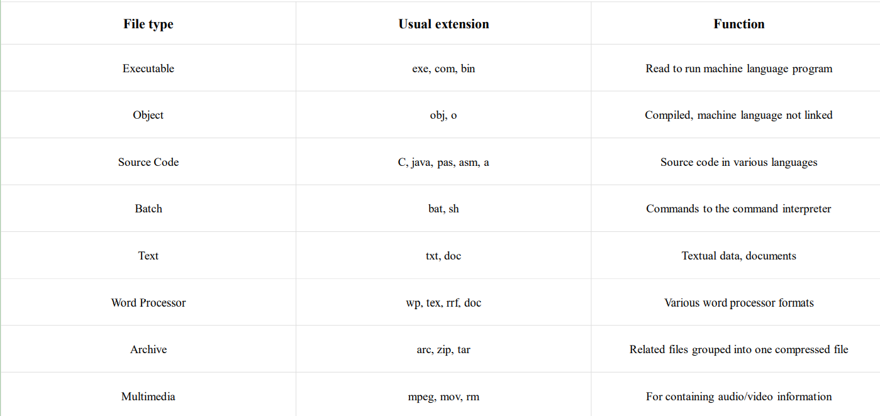

Q4. What are File Directories?
The collection of files is a file directory. The directory contains information about the files, including attributes, location, and ownership. Much of this information, especially that is concerned with storage, is managed by the operating system. The directory is itself a file, accessible by various file management routines.
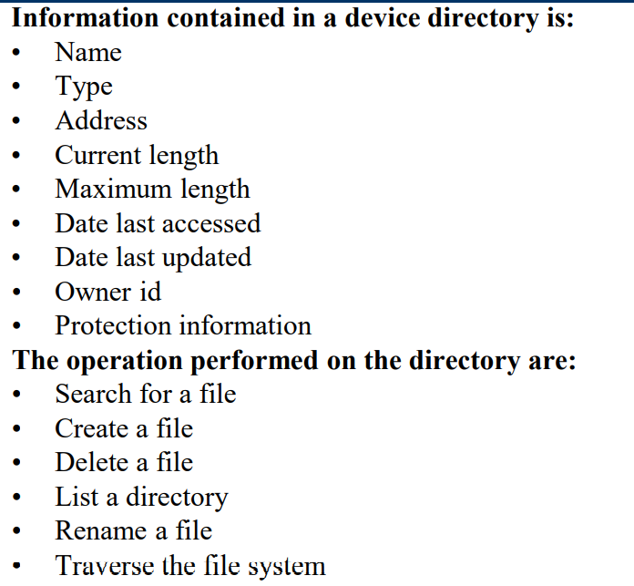

Q5. What is a Physical File System?
A physical file system manages how data is stored and accessed on physical storage devices such as disks or tapes. It deals with the actual data structures and mechanisms used to organize, store, and retrieve data at the hardware level.

Key Aspects:
- Physical Files:
  - Contain the actual data stored on a storage device.
  - Include a description of how data is presented to or received by a program.
  - Can have one record format and one or more members.
- Record Descriptions:
  - Field-level description: Defines the fields in the record explicitly and is used for externally described files.
  - Record-level description: Describes only the length of the record without detailing its contents, used for program-described files.
- Definition:
  - A physical file is essentially a collection of bytes organized and stored on a disk or tape for data persistence and accessibility.

Q6. What is a Logical File System?
A logical file system provides an abstraction layer that manages how files and directories are logically represented and accessed by programs, independent of their physical storage details.

Key Aspects:
- Logical Files:
  - Do not store data themselves but describe the records in one or more physical files.
  - Act as a view or representation of the data stored in physical files.
  - Can include multiformat logical files, which contain multiple record formats.
- Operations and Behavior:
  - Logical files offer a structured view without altering or clearing physical data when opened for processing.
  - Specific functions, like _Rformat(), allow programs to select desired record formats for multiformat logical files.
  - Some operations, such as clearing a file upon opening, cannot be performed directly on logical files.
- Record Descriptions:
  - Field-level description: Provides detailed information about all fields and their arrangement. These are externally described files because the description resides in the database file.
  - Logical files inherit field arrangements from the associated physical files.
- Definition:
  - A logical file serves as a "channel" that abstracts file location and physical format details, simplifying access for programs. This abstraction hides complexity and enhances flexibility.

Q7. Differentiate between Physical and Logical File System.
Aspect | Physical File System | Logical File System
Definition | Manages the actual storage of data on physical media like disk or tape. | Provides an abstraction layer for accessing and managing data in physical files.
Data Storage | Contains actual data stored in bytes. | Does not contain data but describes how to access data from physical files.
Purpose | Handles the structure, allocation, and storage of files on hardware. | Simplifies access by hiding file location and physical format from programs.
Content | Stores data directly, including file records. | Contains metadata or a view of the data in one or more physical files.
Record Formats | Includes a single record format per file. | Can have multiple record formats (e.g., multiformat logical files).
Data Manipulation | Directly reads, writes, and modifies file content. | Provides structured access without modifying the underlying physical data.
Dependency | Exists independently and forms the basis of file storage. | Relies on physical files for data access.
Example | A file stored on disk as a collection of bytes. | A "view" that allows filtered or formatted access to specific fields in the file.

Q8. What is File Allocation? What are its different methods?
File Allocation refers to the method by which files are stored in disk blocks, determining how the operating system organizes files and manages storage. The goal is to ensure efficient disk space utilization and fast file access. There are three primary methods of file allocation:
- Contiguous Allocation
  - Each file occupies a set of contiguous blocks on the disk.
  - The directory stores the starting block address and the length of the file.
  - Advantages:
    - Simple and fast access since all blocks are adjacent.
    - Easy to calculate block locations.
  - Disadvantages:
    - External fragmentation may occur.
    - Difficult to extend files as contiguous space might not be available.
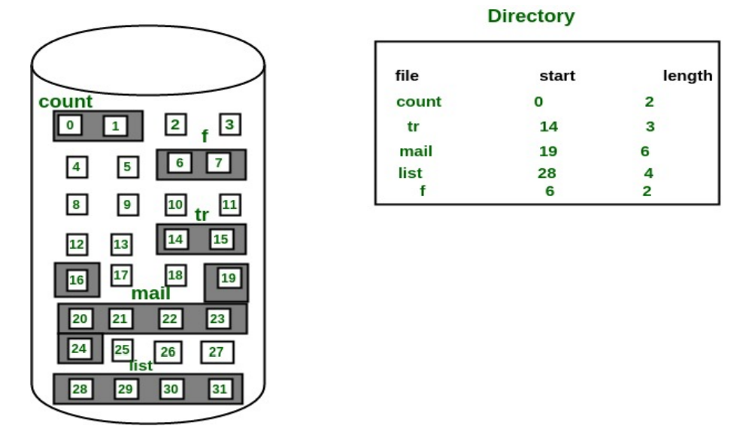

- Linked Allocation
  - Each file is stored as a linked list of blocks, with each block containing a pointer to the next.
  - The directory stores pointers to the start and end blocks.
  - Advantages:
    - No external fragmentation as blocks can be scattered.
    - Easy to grow files dynamically.
  - Disadvantages:
    - Slower access due to sequential traversal.
    - Additional storage needed for pointers.
    - Susceptible to pointer corruption.
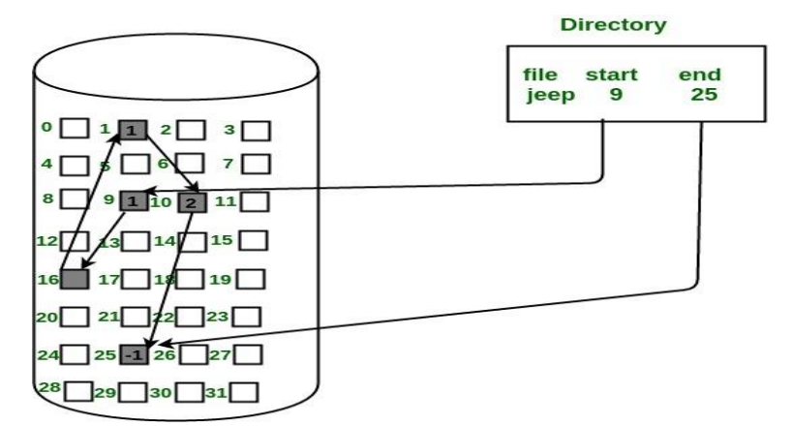
- Indexed Allocation
  - A special index block contains pointers to all blocks of a file.
  - The directory stores the address of the index block.
  - Advantages:
    - Direct access to file blocks.
    - Eliminates fragmentation issues.
  - Disadvantages:
    - Requires additional storage for the index block.
    - May not be efficient for small files as index block overhead is significant.
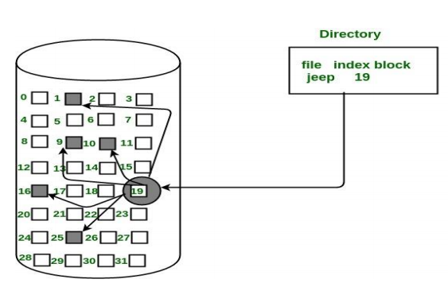
Q9. What is Free Space Management?
Free Space Management refers to the methods used by an operating system to efficiently track and allocate unused disk space on storage devices. Effective management ensures optimal use of storage resources while minimizing fragmentation and ensuring quick access to available blocks. Common techniques include:

- Linked Allocation
  - Free blocks are organized as a linked list.
  - Each block contains a pointer to the next free block.
  - Advantages: Simple implementation, dynamic allocation.
  - Disadvantages: Fragmentation and slower access due to sequential traversal.
- Contiguous Allocation
  - Free blocks are allocated in a contiguous manner.
  - Maintains a list or bitmap to identify contiguous free spaces.
  - Advantages: Fast access and minimal fragmentation for files.
  - Disadvantages: External fragmentation and difficulty in extending files.
- Indexed Allocation
  - Uses an index block to store the addresses of free disk blocks.
  - Tracks free space efficiently without requiring contiguity.
  - Advantages: Eliminates fragmentation and supports dynamic allocation.
  - Disadvantages: Requires extra space for index blocks.
- File Allocation Table (FAT)
  - A FAT structure is used to record free and allocated blocks.
  - Updates occur whenever a file is allocated or deleted.
  - Advantages: Widely used and easy to manage.
  - Disadvantages: High overhead for maintaining the table.
- Volume Shadow Copy
  - Creates backups of files or volumes when changes occur.
  - Used primarily for data recovery and versioning.
  - Advantages: Prevents data loss and supports rollback.
  - Disadvantages: Requires additional storage for shadow copies.
Q10. What is File Access Control?
File Access Control is the mechanism for managing and restricting access to files based on user roles and permissions. It ensures that authorized users can access necessary information while protecting it from unauthorized access or malicious activities. The operating system uses specific techniques and data structures to implement access control effectively.

Key Features:
- User Roles:
  - Owner (User): The creator or primary user of the file with maximum control.
  - Group: A defined set of users with intermediate access privileges.
  - Others: Everyone else with the least access permissions.
- Permission Types:
  - Read (r): Allows viewing the file’s contents.
  - Write (w): Allows modifying the file’s contents.
  - Execute (x): Allows executing the file as a program or script.
- POSIX File Access Control:
  - Permissions are encoded in a 16-bit integer.
  - 7 bits: Indicate file type and other attributes (e.g., directory vs. regular file).
  - 9 bits: Represent permissions for user, group, and others (3 bits each).
- Windows Access Control:
  - Uses an Access Control List (ACL) to define detailed permissions for files.

Permission Representation:
- Permissions for each owner type are encoded as a 3-bit binary pattern.
- Examples of permission combinations:
  - 000: No access.
  - 100: Read-only.
  - 110: Read and write.
  - 111: Full access (read, write, execute).

Importance:
File access control is critical for data security, ensuring only authorized actions are performed on files, protecting sensitive information, and preventing unauthorized modifications or breaches.
Q11. What are the Data Access Technique?
Data access techniques define how a system can read, write, and manipulate data in files stored on secondary storage like hard disks. There are several methods of accessing data, each suitable for different types of applications and file storage strategies. Here are the key data access techniques in detail:

1. Sequential Access
Sequential access is the simplest and most common method of accessing data. In this method, data is read or written in a sequential manner, one record after the other, from the beginning to the end of the file. The file pointer moves from one record to the next in order, without any ability to jump to arbitrary locations.
- Key Points:
  - Data is processed one record at a time in a fixed order.
  - The file pointer automatically advances as records are read or written.
  - This is suitable for operations where all the data needs to be processed in order, such as reading or writing log files, processing text files, or streaming data.
  - Applications: Editors, compilers, batch processing systems, or any system that needs to process data in a linear fashion.
- Example: When reading a file with sequential access, the system first reads the first record, then reads the second, and so on, until the end of the file is reached. Each read operation moves the file pointer forward by one record.
- Advantages:
  - Simple to implement.
  - Efficient for processing large files that need to be read in their entirety.
- Disadvantages:
  - Inefficient for random access, as it requires traversing through all records sequentially before accessing the desired one.
  - Not suitable for applications requiring fast access to specific records.

2. Direct Access (Random Access)
Direct access (also known as random access) allows the system to access any record in the file without the need to go through previous records. Files are viewed as a sequence of fixed-length records, each identified by a unique identifier or position in the file (usually a block number). This technique allows you to directly access any part of the file without needing to read through all preceding data.
- Key Points:
  - Files are divided into fixed-length records.
  - A unique identifier or address (block number) is used to access any specific record.
  - The file system can move directly to the desired record based on its address in the file.
  - Applications: Database management systems, real-time systems, and scenarios requiring efficient, fast access to arbitrary records.
- Example: If a file consists of 100 records, with each record being 100 bytes, direct access would allow you to read record 5 directly by calculating its position (i.e., 5 × 100 bytes). The system can access any record at any time.
- Advantages:
  - Fast access to any record in the file, regardless of its position.
  - Suitable for databases, indexing systems, or situations where data needs to be accessed randomly.
- Disadvantages:
  - Requires additional overhead for managing record positions.
  - Less efficient when the file consists of variable-length records or requires more complex indexing.

3. Index Sequential Access
Index Sequential Access is a hybrid of sequential and direct access methods. In this approach, an index is built for the file, typically in the form of a separate index file. The index stores the addresses of the data records in the file. To find a specific record, the system first looks up the record in the index, then uses the address to access the file and retrieve the record.
- Key Points:
  - Files are accessed sequentially through an index.
  - The index contains pointers to data blocks or records in the file.
  - The index helps speed up searches for specific records.
  - Applications: Used in systems where both sequential processing and random access are needed, such as in databases or large collections of files with frequent searches.
- Example: Consider a file storing employee records. An index file stores the employee ID and its corresponding position in the employee records file. If you need to find an employee by ID, the system searches the index to find the address of the record and then accesses the file directly to read the record.
- Advantages:
  - Provides the efficiency of direct access while still maintaining the simplicity of sequential access.
  - Enables faster searches for specific records compared to pure sequential access.
- Disadvantages:
  - Requires additional storage space for the index.
  - Maintaining the index requires overhead, especially during insertions and deletions of records.

4. Relative Record Access
Relative Record Access allows records to be accessed based on their position relative to the current record, rather than by a specific address. It is often used in systems where records are stored in fixed-length slots, and access is based on relative locations rather than absolute memory addresses.
- Key Points:
  - Records are accessed relative to the current position.
  - Efficient for sequential or batch processing where relative positioning is important.
  - Applications: Used in file systems where records are fixed in size, such as in older systems or low-level applications.
- Example: If you are reading a file and you need to skip 10 records ahead, you simply move the file pointer 10 records forward without needing the absolute location of each record.
- Advantages:
  - Simple and efficient for fixed-length records.
  - Suitable for sequential access with easy positioning.
- Disadvantages:
  - Not suitable for variable-length records.
  - Less flexible compared to random access methods.

5. Content-Addressable Access (CAA)
Content-Addressable Access (CAA) is a specialized method where records are accessed based on their content rather than their location. This method relies on using a hashing function to generate a unique key or address based on the content of the data. When you want to access a specific record, you hash the data you are searching for and use that hash as the "address" to retrieve the record.
- Key Points:
  - Records are accessed by their content (e.g., a key or hash) rather than by their address.
  - Efficient for systems where data retrieval is based on content, such as large-scale databases or caching systems.
  - Applications: Used in distributed systems, file systems with dynamic content, and systems needing fast content retrieval (e.g., blockchain systems or data deduplication systems).
- Example: If you're searching for a record containing a specific string, you calculate a hash of the string and use that hash to quickly locate the corresponding record in a content-addressable memory or database.
- Advantages:
  - Enables efficient access based on content rather than location.
  - Useful for systems with dynamic, changing data.
- Disadvantages:
  - Requires complex hashing algorithms and additional memory management.
  - Not suitable for traditional file systems where content location is predefined.

Q12. What is Data Integrity Protections?
Data integrity refers to the accuracy, completeness, and consistency of data over its lifecycle. It ensures that data remains accurate and unaltered from its creation to its storage and transmission. Data integrity protection ensures that the data is not tampered with, corrupted, or unauthorizedly altered.
While data integrity is concerned with the correctness and validity of data, data protection is primarily about securing data from unauthorized access, theft, or loss. Data integrity is often a byproduct of effective data security practices but focuses more on ensuring that the data remains intact and accurate rather than just protecting it from external threats.
Data integrity protection can be achieved using various techniques:
- Checksums and Hash Functions: These are used to verify that the data has not been altered. Any change in the data would lead to a mismatch in the checksum or hash, indicating tampering.
- Cryptographic Methods: Techniques like digital signatures or encryption ensure that the data cannot be altered without detection.
- Access Controls: Limiting who can access or modify the data ensures that only authorized individuals can make changes, thus preserving its integrity.
- Backup and Versioning: Regular backups and maintaining multiple versions of data ensure that corrupted or altered data can be restored to its original form.
In summary, data integrity protection focuses on ensuring that data remains accurate, uncorrupted, and consistent throughout its lifecycle, often relying on encryption, access control, and verification techniques to prevent unauthorized modifications.

Q13. Case Study on file system: FAT32, NTFS, Ext2/Ext3 etc.

Case Study on File Systems: FAT32, NTFS, Ext2/Ext3
File systems are a crucial part of operating systems as they define how data is stored, accessed, and managed on storage devices like hard drives, SSDs, and flash drives. Different file systems have evolved over the years to meet the demands of growing storage sizes, improved data access speeds, and more complex operating system environments. This case study focuses on FAT32, NTFS, and Ext2/Ext3, some of the most commonly used file systems, and their evolution, design, and features.

1. FAT (File Allocation Table) File System
The File Allocation Table (FAT) file system was first introduced in 1977 with the Microsoft MS-DOS operating system, based on the work of Tim Paterson and the QDOS system. FAT was designed to be a simple, efficient, and easy-to-implement file system that could work with relatively small storage devices and early computer hardware. The FAT file system has gone through several versions over the years, each improving on the previous one.

FAT12, FAT16, FAT32:
- FAT12 was the original version, designed for floppy disks. It could handle storage sizes up to 32MB.
- FAT16 expanded the capabilities to handle hard drives, allowing for partition sizes up to 2GB.
- FAT32, introduced in 1996 with Windows 95, was the most popular version of FAT. It supported much larger disk sizes, up to 2TB (with a 32GB partition size limit in Windows). It also increased the maximum file size to 4GB.

Key Features of FAT32:
- Simple and lightweight, making it suitable for use in embedded systems, flash drives, and memory cards.
- Widely compatible across many operating systems (Windows, macOS, Linux).
- Does not support advanced features like file permissions or journaling.
- Fragmentation issues can occur as the file system ages, leading to performance degradation.
- Limited support for file size (4GB max).

2. NTFS (New Technology File System)
NTFS is a modern file system developed by Microsoft and introduced with Windows NT in 1993. It was designed to overcome the limitations of the older FAT systems, providing better performance, scalability, and security features. NTFS is the default file system in all modern versions of Windows.

Key Features of NTFS:
- Security: NTFS supports file-level security with Access Control Lists (ACLs), enabling detailed permissions for users and groups.
- Journaling: NTFS uses a journaling feature, which logs changes to files before committing them. This improves data integrity and makes recovery from crashes easier.
- Compression: NTFS supports file compression, allowing users to save space by storing files in a compressed format.
- Encryption: NTFS includes support for Encrypting File System (EFS), allowing files to be encrypted for added security.
- Large File and Volume Sizes: NTFS supports large file sizes (up to 16TB) and large volumes (up to 256TB), making it suitable for modern computing environments.
- Reliability: Through its journaling mechanism, NTFS can recover from system crashes and errors more effectively than FAT32.

Advantages over FAT32:
- Supports large volumes and files without the limitations of FAT32.
- Better data protection and integrity with journaling and security features.
- More efficient use of disk space, reducing fragmentation issues.
- Supports file permissions, encryption, and other enterprise-level features.

Disadvantages of NTFS:
- Less compatible with non-Windows operating systems.
- Slower performance on smaller devices (like flash drives) compared to FAT32 due to the overhead of advanced features.

3. Ext2/Ext3 File Systems
The Ext2 (Second Extended File System) and Ext3 (Third Extended File System) are the primary file systems used in Linux-based operating systems. Ext2 was introduced in 1993, while Ext3 was introduced in 2001 as a journaling version of Ext2.

Ext2:
- Ext2 is a non-journaling file system, which makes it faster than Ext3 in some scenarios but less reliable in the event of power failure or system crashes.
- Designed for use in systems where data integrity is not as critical, or where the system is used in a controlled environment with low risk of crashes.
- Ext2 was widely used in early Linux systems, particularly for hard drives and partitions without the need for a journal.

Ext3:
- Ext3 is an improved version of Ext2 with journaling capabilities. It keeps track of changes before they are written to the disk, ensuring that in case of a crash, the file system can recover without significant data loss.
- Backward Compatibility: Ext3 is backward compatible with Ext2, meaning that a partition formatted with Ext2 can be converted to Ext3 without data loss.

Key Features of Ext3:
- Journaling: Ext3 ensures data integrity by maintaining a journal of file changes. This prevents file system corruption due to sudden shutdowns.
- Large Volume Support: Ext3 supports volumes up to 32TB and files up to 2TB, making it suitable for large-scale storage needs.
- Efficient Disk Space Utilization: Similar to NTFS, Ext3 uses efficient allocation methods to minimize fragmentation and improve performance over time.
- Compatibility with Linux: Ext3 is one of the most common file systems in Linux, with widespread support across various distributions.

Advantages of Ext3/Ext2:
- Journaling in Ext3 improves data integrity and recovery.
- Stable and Reliable: Both file systems are mature and widely used in Linux environments.
- Efficient Performance: Ext3 offers good performance with large files and directories.
- Easy to Use: Ext2 and Ext3 are relatively simple to set up and manage.

Disadvantages:
- Ext2 lacks journaling, making it less reliable in the event of a crash or power failure.
- Ext3 can have performance overhead due to journaling, especially in high-performance environments.
- Ext3 does not offer as many features as NTFS, such as file compression, encryption, or detailed file-level security.

Comparison of FAT32, NTFS, and Ext2/Ext3
Feature | FAT32 | NTFS | Ext2/Ext3
Maximum File Size | 4GB | 16TB | 2TB (Ext2/Ext3)
Maximum Volume Size | 2TB | 256TB | 32TB (Ext3)
Journaling | No | Yes | Yes (Ext3 only)
Security | No | Yes (ACLs, EFS) | Limited (Ext2)
Compression | No | Yes | No
File Permissions | No | Yes (ACLs, NTFS permissions) | No (Ext2), Limited (Ext3)
Operating System | Windows, some Linux/Unix | Windows only | Linux
Data Integrity | Low (prone to corruption) | High (journaling) | Moderate (Ext3 has journaling)

Conclusion
Each file system has its strengths and weaknesses, depending on the needs of the user and the system environment.
- FAT32 is simple and universally compatible but is limited by file size and volume size restrictions.
- NTFS is a modern, robust file system ideal for Windows environments, offering advanced features like security, journaling, and compression, but it is less compatible with non-Windows systems.
- Ext2/Ext3 are ideal for Linux-based systems, with Ext3 offering data integrity through journaling. Ext2 is simpler and faster but lacks reliability in the event of crashes.
The choice of file system depends on the operating system in use, the storage requirements, and the need for features such as security, data recovery, and performance.
PYQ QUESTIONS
(2024)
- Distinguish between batch systems and time-sharing systems. 3*
Aspect | Batch Systems | Time-Sharing Systems
Concept | Processes are grouped into batches and executed sequentially. | Multiple users share CPU time through time slices, appearing as simultaneous execution.
User Interaction | No real-time interaction; input is provided in bulk. | Allows real-time user interaction with immediate feedback.
Efficiency | More efficient for long, non-interactive jobs. | Maximizes CPU usage by allocating small time slices to each user.
Resource Management | Jobs are processed one after another, leading to less CPU idle time. | CPU is divided into small time slices, giving the illusion of simultaneous execution.
Examples | Early mainframe systems, traditional batch jobs. | Multi-user systems like UNIX, modern time-sharing systems.

- State the lifecycle of Thread. 3*
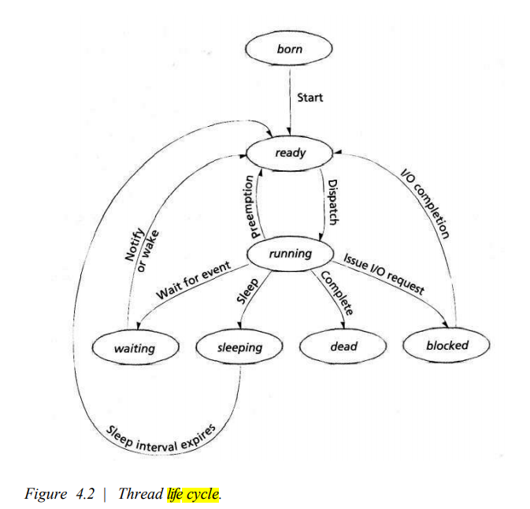

- What are the various file operations? 3*
File Operation | Description
Create | Initializes a new file, allocating space for its content.
Open | Allows access to an existing file for reading, writing, or appending.
Read | Retrieves data from a file, typically into memory for processing.
Write | Adds or modifies data in the file.
Append | Adds data to the end of the file without modifying existing content.
Close | Releases any resources associated with the file and saves changes.
Delete | Removes the file from the file system permanently.
Rename | Changes the file's name.
Seek | Moves the file pointer to a specific location within the file.
Truncate | Shortens the file to a specified length, removing any extra data.

- Define the terms Caching and Buffering. 3*
Caching and Buffering are two techniques used to optimize performance in computing systems, but they serve different purposes:
- Caching:
  - Caching refers to the process of storing frequently accessed data in a faster storage medium (like RAM or CPU cache) so that future requests for that data can be served more quickly.
  - It helps reduce data retrieval time by keeping copies of data that are expensive or slow to fetch.
  - Example: Storing website data in the browser cache to avoid re-fetching it from the internet.
- Buffering:
  - Buffering involves temporarily storing data in a memory area (buffer) while it is being transferred between two devices or processes that operate at different speeds.
  - It helps smooth out inconsistencies in the flow of data, preventing data loss and ensuring continuous data processing.
  - Example: Using a buffer to hold data being written to a disk while the disk is busy processing previous data.
Both techniques enhance system efficiency but address different challenges related to data access and transfer.

- Write two advantages of virtual memory concept. 3*
- Efficient Use of System Resources:
  - Virtual memory allows a system to run larger programs than the available physical memory by using disk space as temporary storage. This enables multiple programs to run simultaneously without running out of physical RAM, optimizing the overall utilization of system resources.
- Isolation and Protection:
  - Virtual memory provides memory isolation for different processes, ensuring that one process cannot access or modify the memory space of another. This enhances system stability and security by preventing one program from interfering with others, reducing the risk of data corruption or crashes.

UNIT-I

- Discuss the services provided by the operating system. 4*
Here are the key services provided by an operating system:
Process Management: Manages processes by handling creation, scheduling, and termination.
Memory Management: Allocates and manages memory, ensuring efficient use through techniques like paging.
File System Management: Organizes and manages files, ensuring secure access and storage.
Device Management: Controls hardware devices through device drivers and abstracts their complexities.
Security and Access Control: Protects system data and resources with authentication and access control.
User Interface: Provides interfaces (command-line or graphical) for user interaction with the system.
- Explain Process Control Block. Draw the block diagram of process transition states. 6*
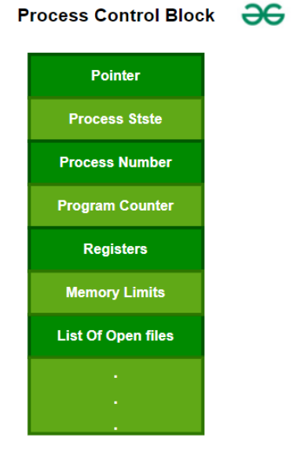
A Process Control Block (PCB) is a data structure used by the operating system to manage information about a process. The process control keeps track of many important pieces of information needed to manage processes efficiently. The diagram helps explain some of these key data items
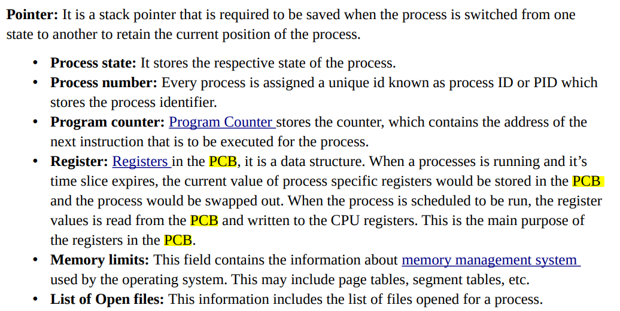

- Describe the different types of process schedulers. 5*
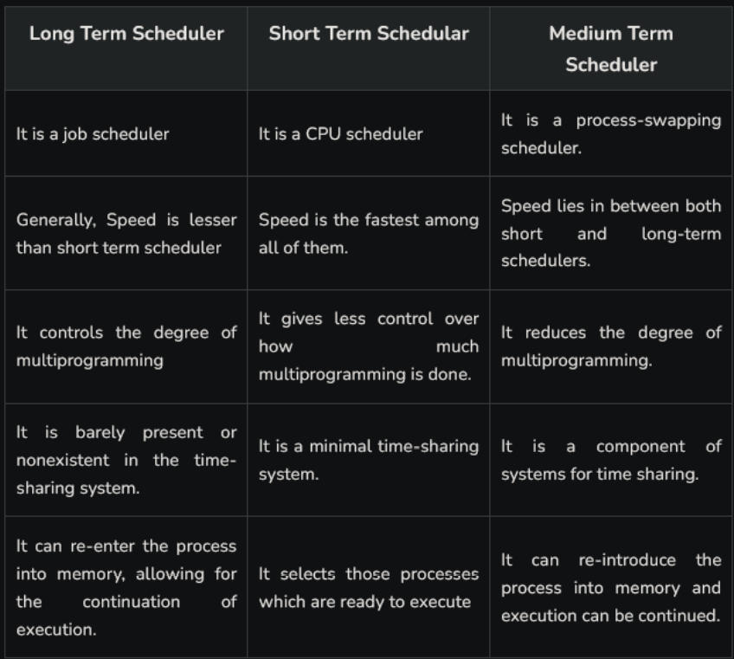

- Assume the following workload in a system:

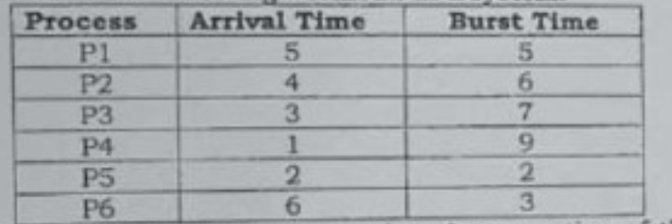

Draw a Gantt chart illustrating the execution of these jobs using Round Robin and Shortest Job First (SJF) scheduling algorithm and also calculate the average waiting time and average turnaround time. Highlight the advantages of each algorithm through the calculated metrics. 10*

- Illustrate the significance of the terms demand scheduling and real time scheduling. 5*
Demand scheduling refers to the scheduling approach where processes are initiated or scheduled based on system demand or the availability of resources. It doesn't follow a fixed pattern but depends on the current workload and resource utilization.
Real-time scheduling refers to the scheduling of tasks that must be completed within a specific time constraint, typically under strict deadlines. These systems are designed to handle tasks that require immediate and predictable responses.
Feature | Demand Scheduling | Real-time Scheduling
Objective | Schedule based on system demand and resource availability. | Schedule based on time constraints, ensuring deadlines are met.
Type of Tasks | General-purpose tasks like batch processing, interactive tasks. | Time-critical tasks that must meet strict deadlines.
Resource Allocation | Resources are allocated dynamically based on demand. | Resources are allocated to ensure timely completion.
Use Cases | Time-sharing systems, batch processing. | Embedded systems, medical devices, industrial control.
Flexibility | More flexible; adapts to changing loads and priorities. | Less flexible; strict adherence to deadlines is crucial.

UNIT-II

- What are the advantages of inter-process communication? How communication takes place in a shared-memory environment? 7.5*
Advantages of Inter-Process Communication (IPC):
  - Resource Sharing: Enables processes to share resources efficiently.
  - Data Exchange: Allows processes to exchange data seamlessly.
  - Synchronization: Coordinates process actions to avoid conflicts.
  - Modularity: Promotes modular application design and performance.
  - Deadlock Avoidance: Helps prevent or manage deadlocks.
  - Security: Enforces security policies during process communication.
  - Concurrency: Supports concurrent process execution without interference.

Communication in a Shared-Memory Environment:
  - Memory Sharing: Multiple processes share a portion of memory.
  - Access Control: Synchronization mechanisms prevent concurrent access issues.
  - Data Exchange: Processes read/write data directly from shared memory.
  - Efficiency: Faster than message passing, but requires proper synchronization.

- Define and implement the hardware solution to mutual exclusion problem. 7.5*

Definition of Mutual Exclusion:
Mutual exclusion is a fundamental concept in concurrent programming, ensuring that multiple processes or threads do not simultaneously execute critical sections of code that manipulate shared resources. This prevents data inconsistency, race conditions, and system instability. The goal is to allow only one process to enter the critical section at any given time.

Hardware Solution to the Mutual Exclusion Problem:
One hardware-based solution to achieve mutual exclusion is through atomic instructions provided by the hardware. These instructions ensure that a particular operation (e.g., setting a flag or updating a shared variable) is performed without interruption, preventing other processes from accessing the shared resource during that time.

Hardware Solutions:
- Test-and-Set: This is an atomic instruction that reads a value from a memory location and sets it to a new value in a single atomic operation. It helps in locking a resource to ensure mutual exclusion.
- Compare-and-Swap: This atomic instruction compares the contents of a memory location with a given value and, if they are the same, swaps it with a new value. It can also be used for mutual exclusion to prevent race conditions.

Implementation of Test-and-Set in Hardware:
The Test-and-Set instruction can be implemented in hardware as follows:
- Shared Variable (Lock): A shared variable, typically called lock, is used to manage the mutual exclusion. The value of lock is initially set to false (unlocked).
- Atomic Operation: When a process wants to enter the critical section, it executes the Test-and-Set operation on the lock variable:
  - If the lock is false, it is atomically changed to true, allowing the process to enter the critical section.
  - If the lock is already true, the process keeps testing it in a loop (busy waiting) until it becomes false.

Pseudo-code for Test-and-Set:
lock = False # Shared variable

def test_and_set():
global lock
old_value = lock
lock = True # Set the lock to True to prevent other processes
return old_value # Return the previous value of the lock

def critical_section():
# Code for the critical section that needs exclusive access to resources
pass

def process():
while True:
if not test_and_set():
critical_section()
lock = False # Release the lock after completing the critical section
break # Exit the loop after critical section execution

Explanation:
- test_and_set: It atomically checks and sets the lock variable to True. If the lock was already True, the process has to wait (busy waiting) until it is set back to False.
- critical_section: The part of the code where shared resources are accessed.
- process: This simulates the process trying to enter the critical section, checking and setting the lock accordingly.

Advantages of Hardware Solutions:
- Atomicity: The operations are performed without interruption, ensuring mutual exclusion.
- Efficiency: Direct hardware support minimizes overhead compared to software-based solutions.
- Speed: Hardware-level synchronization is faster than software-based mutual exclusion mechanisms like semaphores or monitors.

Disadvantages:
- Busy Waiting: The process may waste CPU time by continuously checking the lock (especially if contention is high).
- Starvation: In case of high contention, some processes may never get access to the critical section.

- Explain with a neat diagram the concept of segmentation with paging in virtual memory. What problem does it solve? 7*
Paged segmentation is a memory management technique that combines the concepts of paging and segmentation. In this scheme, a process is divided into segments, which are then further divided into fixed-size pages. This allows for more flexible memory allocation and efficient use of memory resources.
Key features of paged segmentation include:
• Segmentation: The process is divided into segments, each representing a logical unit such as a procedure or data structure. These segments can vary in size.
• Paging: Each segment is divided into fixed-size pages, allowing the system to manage memory in a more granular way. The size of the pages is typically uniform, making it easier to allocate and manage memory.
• Segment Table: Each segment has an associated segment table that contains the base address of the segment in physical memory and the segment limit.
• Page Table: Each segment also has a page table that maps the logical pages of that segment to physical frames in memory
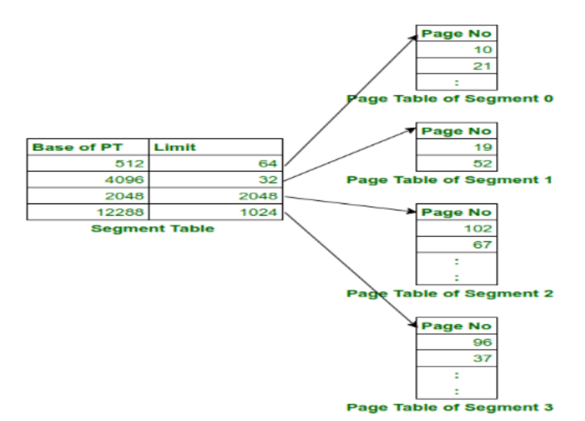
Problem Solved by Segmentation with Paging:
- Eliminates External Fragmentation:
In pure segmentation, segments could have variable sizes, leading to external fragmentation. Paging solves this by dividing segments into fixed-size pages.
Since pages are of fixed size, they fit neatly into physical memory, and unused memory blocks (frames) can be reused.
- Combines the Benefits of Both:
Segmentation provides logical division of memory, making it easier to manage different types of data (code, stack, heap).
Paging eliminates the issues of fragmentation, ensuring efficient use of physical memory.
This combination ensures that the program is efficiently divided into both logical (segments) and physical (pages) units, improving memory management.
- Overcomes the Limitation of Large Segments:
In pure segmentation, large segments could be difficult to fit into memory, leading to wasted space and inefficient memory usage. By breaking segments into smaller pages, this problem is alleviated.
- Improves Flexibility and Efficiency:
This scheme allows processes to use non-contiguous physical memory, increasing the effective use of available RAM.
The paging system ensures that only the needed pages are loaded into memory, enabling demand paging, where pages are loaded into memory only when required.
- Consider the following reference string
5, 6, 1, 2, 6, 3, 6, 4, 2, 3, 6, 3, 2, 1, 2, 6, 1, 5, 6, 1
Find the number of Page Faults with FIFO, Optimal Page replacement and LRU with four free frames which are empty initially. Which algorithm gives the minimum number of page faults? 8*

UNIT-III

- How does deadlock avoidance differ from deadlock prevention? (3)
Aspect | Deadlock Avoidance | Deadlock Prevention
Goal | Ensures that deadlock is avoided by dynamically analyzing the resource allocation state. | Ensures that deadlock cannot occur by preventing one of the necessary conditions for deadlock.
Approach | Uses algorithms like Banker's Algorithm to make decisions that avoid unsafe states. | Enforces conditions like mutual exclusion or holds and waits that make deadlock impossible.
Resource Allocation | Resources are allocated only if it doesn't lead to a potential deadlock. | Prevents circular waits by limiting how processes acquire resources.

- Explain resource allocation graph with a suitable example. (4)
- Using Banker's algorithm, find the safe sequence for the following scenario: 8*
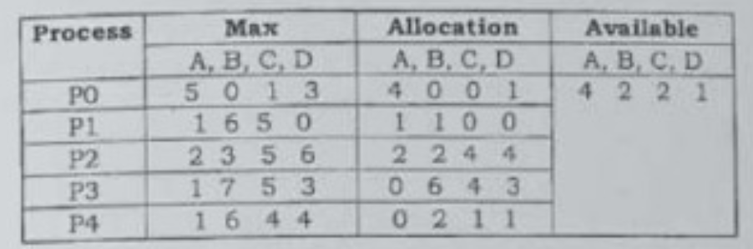
- A disk drive has 200 cylinders, numbered 0 to 199. The drive is currently serving a request at cylinder 53. The queue of pending requests, in FIFO order, is 99, 173, 27, 122, 14, 128, 60, 67. Starting from the current head position, what is the total distance (in cylinders) that the disk arm moves to satisfy all the pending requests for each of the following disk-scheduling algorithms? i) FCFS ii) SSTF iii) SCAN iv) C-SCAN v) C-LOOK (10)

- Discuss and differentiate seek time, rotational latency and disk access time. (5)

Seek Time, Rotational Latency, and Disk Access Time
- Seek Time:
  - Definition: Seek time is the time taken by the disk's read/write head to move to the correct track on the disk where data is stored.
  - Cause: Depends on the distance the read/write head must move.
  - Impact: It is the major component of disk access time for mechanical hard drives.
  - Average Seek Time: Typically measured in milliseconds (ms) and often averaged over many random accesses.
- Rotational Latency:
  - Definition: Rotational latency is the time taken for the disk to rotate and position the required data under the read/write head after the seek operation.
  - Cause: Dependent on the speed of the disk's rotation (RPM).
  - Impact: Increases with slower disk rotation speeds and larger amounts of data being accessed.
  - Average Rotational Latency: For a disk rotating at 5400 RPM, the average rotational latency is about 5.55 ms.
- Disk Access Time:
  - Definition: Disk access time is the total time taken to access a specific piece of data from the disk. It is the sum of seek time and rotational latency.
  - Formula: Disk Access Time=Seek Time+Rotational Latency\text{Disk Access Time} = \text{Seek Time} + \text{Rotational Latency}
  - Impact: It is the overall time to retrieve data, impacting system performance. Reducing either seek time or rotational latency improves access time.

Differentiation:
Aspect | Seek Time | Rotational Latency | Disk Access Time
Definition | Time to move the read/write head to the correct track | Time for the disk to rotate to the correct position | Total time to access data from disk
Cause | Movement of the head to the right track | Disk rotation to position the sector | Sum of seek time and rotational latency
Impact on Performance | Major impact on access time for mechanical disks | Affects data retrieval depending on disk speed | Directly affects overall data retrieval time
Unit | Measured in milliseconds (ms) | Measured in milliseconds (ms) | Measured in milliseconds (ms)
Example | 10ms for a medium-range disk | 5.5ms on average for a 5400 RPM disk | Seek time (10ms) + Rotational latency (5.5ms) = 15.5ms

UNIT-IV

- List and define the various file attributes. (5)
File Attribute | Description
File Name | The name assigned to the file, which is used to identify it in the file system.
File Type | Specifies the type of data stored in the file (e.g., text, executable, image).
File Size | Represents the amount of data stored in the file, typically measured in bytes.
File Location | Indicates the physical or logical location of the file on the storage medium.
File Permissions | Defines the access rights (read, write, execute) granted to the user, group, and others.
Creation Date | The date and time when the file was created.
Last Access Time | The last date and time the file was accessed.
Last Modified Time | The last date and time when the file was modified.
File Owner | The user who owns the file and has control over its permissions and attributes.

- Describe the different accessing methods of a file. (5)
Access Method | Description
Sequential Access | Data is accessed in a sequential manner, one record after another. It is the simplest and most common method, where the file pointer advances after each read or write operation. Commonly used in tape drives.
Direct Access | Also known as random access, allows data to be accessed directly at any position. The file is treated as a sequence of blocks, and records can be read or written in any order. It is commonly used in disk storage.
Index Sequential Access | Combines sequential and direct access methods. An index is used to locate data blocks in the file, enabling both sequential and direct access to records. Suitable for large files.
Relative Record Access | Records are accessed based on their position relative to the current position of the file pointer. Suitable for fixed-length records, often used in databases.
Content-Addressable Access | Data is accessed based on its content rather than its address. A unique key is generated using a hash function, allowing quick lookup of records by their content. Commonly used in distributed systems and specialized databases.

- What are the functions of virtual file system (VFS)? (5)
The Virtual File System (VFS) provides an abstraction layer that allows an operating system to support multiple file systems in a uniform way. Here are its key functions:
Abstraction of File Systems: VFS provides a unified interface for accessing different file systems, allowing applications to interact with any underlying file system (e.g., ext4, FAT32, NTFS) without knowing the details of each.
File System Interoperability: It allows different file systems to be mounted and accessed simultaneously. This enables compatibility between various storage devices and file systems.
File Operations Management: VFS defines standard file operations such as open, close, read, write, and seek, allowing these operations to be executed on files regardless of the underlying file system.
File System Switching: VFS supports switching between file systems without affecting the user's experience. It enables mounting/unmounting of file systems dynamically during runtime.
Caching and Buffering: VFS manages caching and buffering of file data, improving performance by reducing disk I/O operations and optimizing access to files across different file systems.

- Write short notes on: (3×5=15)
  - File directory structures.
  - Ext2/Ext3
  - Data Integrity Protection

A. File Directory Structures
File directory structures organize files on a storage device for efficient access. Common types include:
- Single-Level Directory: All files are stored in one directory, making it simple but not scalable for large systems.
- Two-Level Directory: It introduces a separate directory for each user, allowing for better organization and access control.
- Hierarchical Directory: This is the most common structure, where directories can contain subdirectories, forming a tree structure. It provides better organization and scalability.
- Hashing Directory: Uses a hash function to quickly locate files by their names, improving access speed.

B. Ext2/Ext3
- Ext2 (Second Extended File System): It is a widely used Linux file system known for its simplicity and efficiency. It does not support journaling, meaning that in the event of a crash, data might be corrupted.
- Ext3 (Third Extended File System): An improvement over Ext2, Ext3 supports journaling, which logs changes before writing to the disk. This ensures data consistency and allows faster recovery after a crash. Ext3 is backward-compatible with Ext2, making it a popular choice for many Linux systems.

C. Data Integrity Protection
Data integrity protection ensures that data remains accurate, consistent, and unaltered during storage, transfer, or processing. This protection is achieved through:
- Checksums and Hash Functions: These methods generate a unique value for data, allowing for easy detection of corruption or unauthorized changes.
- Encryption: Protects data from unauthorized access, ensuring only authorized users can modify or read it.
- Backup Systems: Regular backups help restore data in case of corruption or loss. Data integrity is crucial in maintaining the trustworthiness of data, particularly in critical applications like banking and healthcare.

(2023)
- What is the meaning of the term busy waiting? What other kinds of waiting are there in an operating system? Can busy waiting be avoided altogether? Explain your answer. (5)
- What is multiprogramming operating system? How it is different from Multiprocessing. Explain. (5)
- Explain Process Control Block with the help of suitable diagram in detail. (5)
- Explain race condition with suitable example? (5)
- What are the four conditions that must be present for a deadlock to be possible? (5)
- What are various file attributes? (5)

UNIT-I

- Explain the layered approach of Operating System? What are main task of OS? [6]
- Given Memory Partitions of 100K,500K,200K,300K and 600K (in order), how would each of the first fit, best fit, and worst fit algorithms place processes of 212K,417K,112K and 426K (in order)? Which algorithms make the most efficient use of memory? [6.5]
- Explain the difference between logical and physical addresses. [3]
- Why are pages sizes always power of 2? [3]
- Consider there are 4 frames allocated to a process and the page reference string is:
7,0,1,2,0,3,0,4,2,3,0,3,2,1,2,0,1,7,0,1
Calculate the number of page faults for the FIFO and LRU page replacement algorithms [6.5]

UNIT-II

- Consider the following set of processes with the CPU burst & arrival time in milliseconds. [6.5]
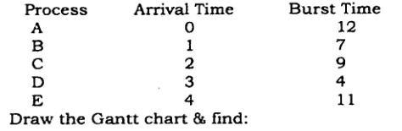

  - Average waiting time for these processes with the Shortest Remaining Time First, Round Robin (Time quantum- 3ms) & FCFS scheduling algorithm.
  - Average turnaround time for these processes with the SRTF, Round Robin & FCFS Algo.
- Explain the Dining Philosophers classical IPC problem and its solution. [6]
- What is thread? What are the differences between user-level threads and kernel-level threads? Under what circumstances is one type better than the other? [6]
- Explain bakery algorithm. Prove that it satisfy all the three requirements for critical section problem. [6.5]

UNIT-III

- A disk with 1000 cylinders, numbered 0 to 999, compute the number of tracks the disk arms must move to satisfy the entire request in the disk queue. Assume the current request serviced is at track 345 and head is moving towards track 0.The queue in FIFO order contains request for the following tracks: 123,874,692,400,475,105,376. Perform the computation for the following scheduling algorithm- (1) FIFO (2) SSTF (3) SCAN (4) C-SCAN (5) LOOK [6.5]
- Explain resource allocation graph. [3]
- What is Safe state? Explain with the help of suitable example.[3]
- Explain Bankar's Algorithm including safety algorithm & resource request algorithm? *6

UNIT-IV

- Explain various types of file and file access methods? [6.5]
- What do you mean by directory structure? Explain various directory structures with suitable diagram? *6
- Write short notes on any two: - *12.5
- Logical file system v/s Physical file system
- FAT v/s NTFS
- Explain various file allocation strategies

